**Contents**

NOTES: 2

Developing Immersive Applications: Recorded live coding stream on "Implementing Interactions" 4

Installing plugins 4

Deploying to Production Server (instead of Dev Server) 7

Refactoring codes 8

Text Component 10

Mesh Component 14

Creating Ground Plane 17

Interactions (Moving Sphere) 18

Observables (Console log) 20

Action Behaviours 24

Mouse Input 24

Keyboard Input 30

Observables (Collision) 33

Observables (Collision checking distance) 37

Observables (Displaying distance) 41

Coroutines 43

Locomotion 47

Hand Tracking (Requires Oculus Quest 2) 51

Bimanual interaction (Requires Oculus Quest 2) 54

Gizmo (Not Working for me! ) 55

Natural Grabbing 58

Final Code Changes 61

webpack.json 61

tsconfig.json 62

app.ts 63

components\meshes\index.ts 74

components\meshes\text-plane.ts 75

components\meshes\hello-mesh.ts 76

# NOTES:

- If you haven’t done Part 1 yet, here’s the link to [Part 1](IPAsetup_part1.docx)

- If you haven’t done Part 2 yet, here’s the link to [Part 2](IPAsetup_part2.docx)

**TOPICS COVERED:**

* Component Classes
* Creating a ground plane
* Moving sphere around
* Observables
* Mouse/Keyboard inputs
* Collision
* Coroutines
* Locomotion (Teleportation/Controller/Walking)
* HandTracking (Using Oculus Quest 2 HMD)
* Bimanual interaction (Using Oculus Quest 2 controllers)
* Gizmo (Sadly, it is not working on my side ☹)
* Natural Grabbing

**FINAL CODE CHANGES:**

Skip to the final code changes:

Final Code Changes

Skip to the individual file changes:

webpack.config.js

tsconfig.json

app.ts

components\meshes\index.ts

components\meshes\text-plane.ts

components\meshes\hello-mesh.ts

# Developing Immersive Applications: Recorded live coding stream on "Implementing Interactions"

<https://www.youtube.com/watch?v=8zXOif9Ys8c>

## Installing plugins

Enter the following commands in WSL:

npm i copy-webpack-plugin -D

You should be able to see "copy-webpack-plugin" added to your "devDependencies"

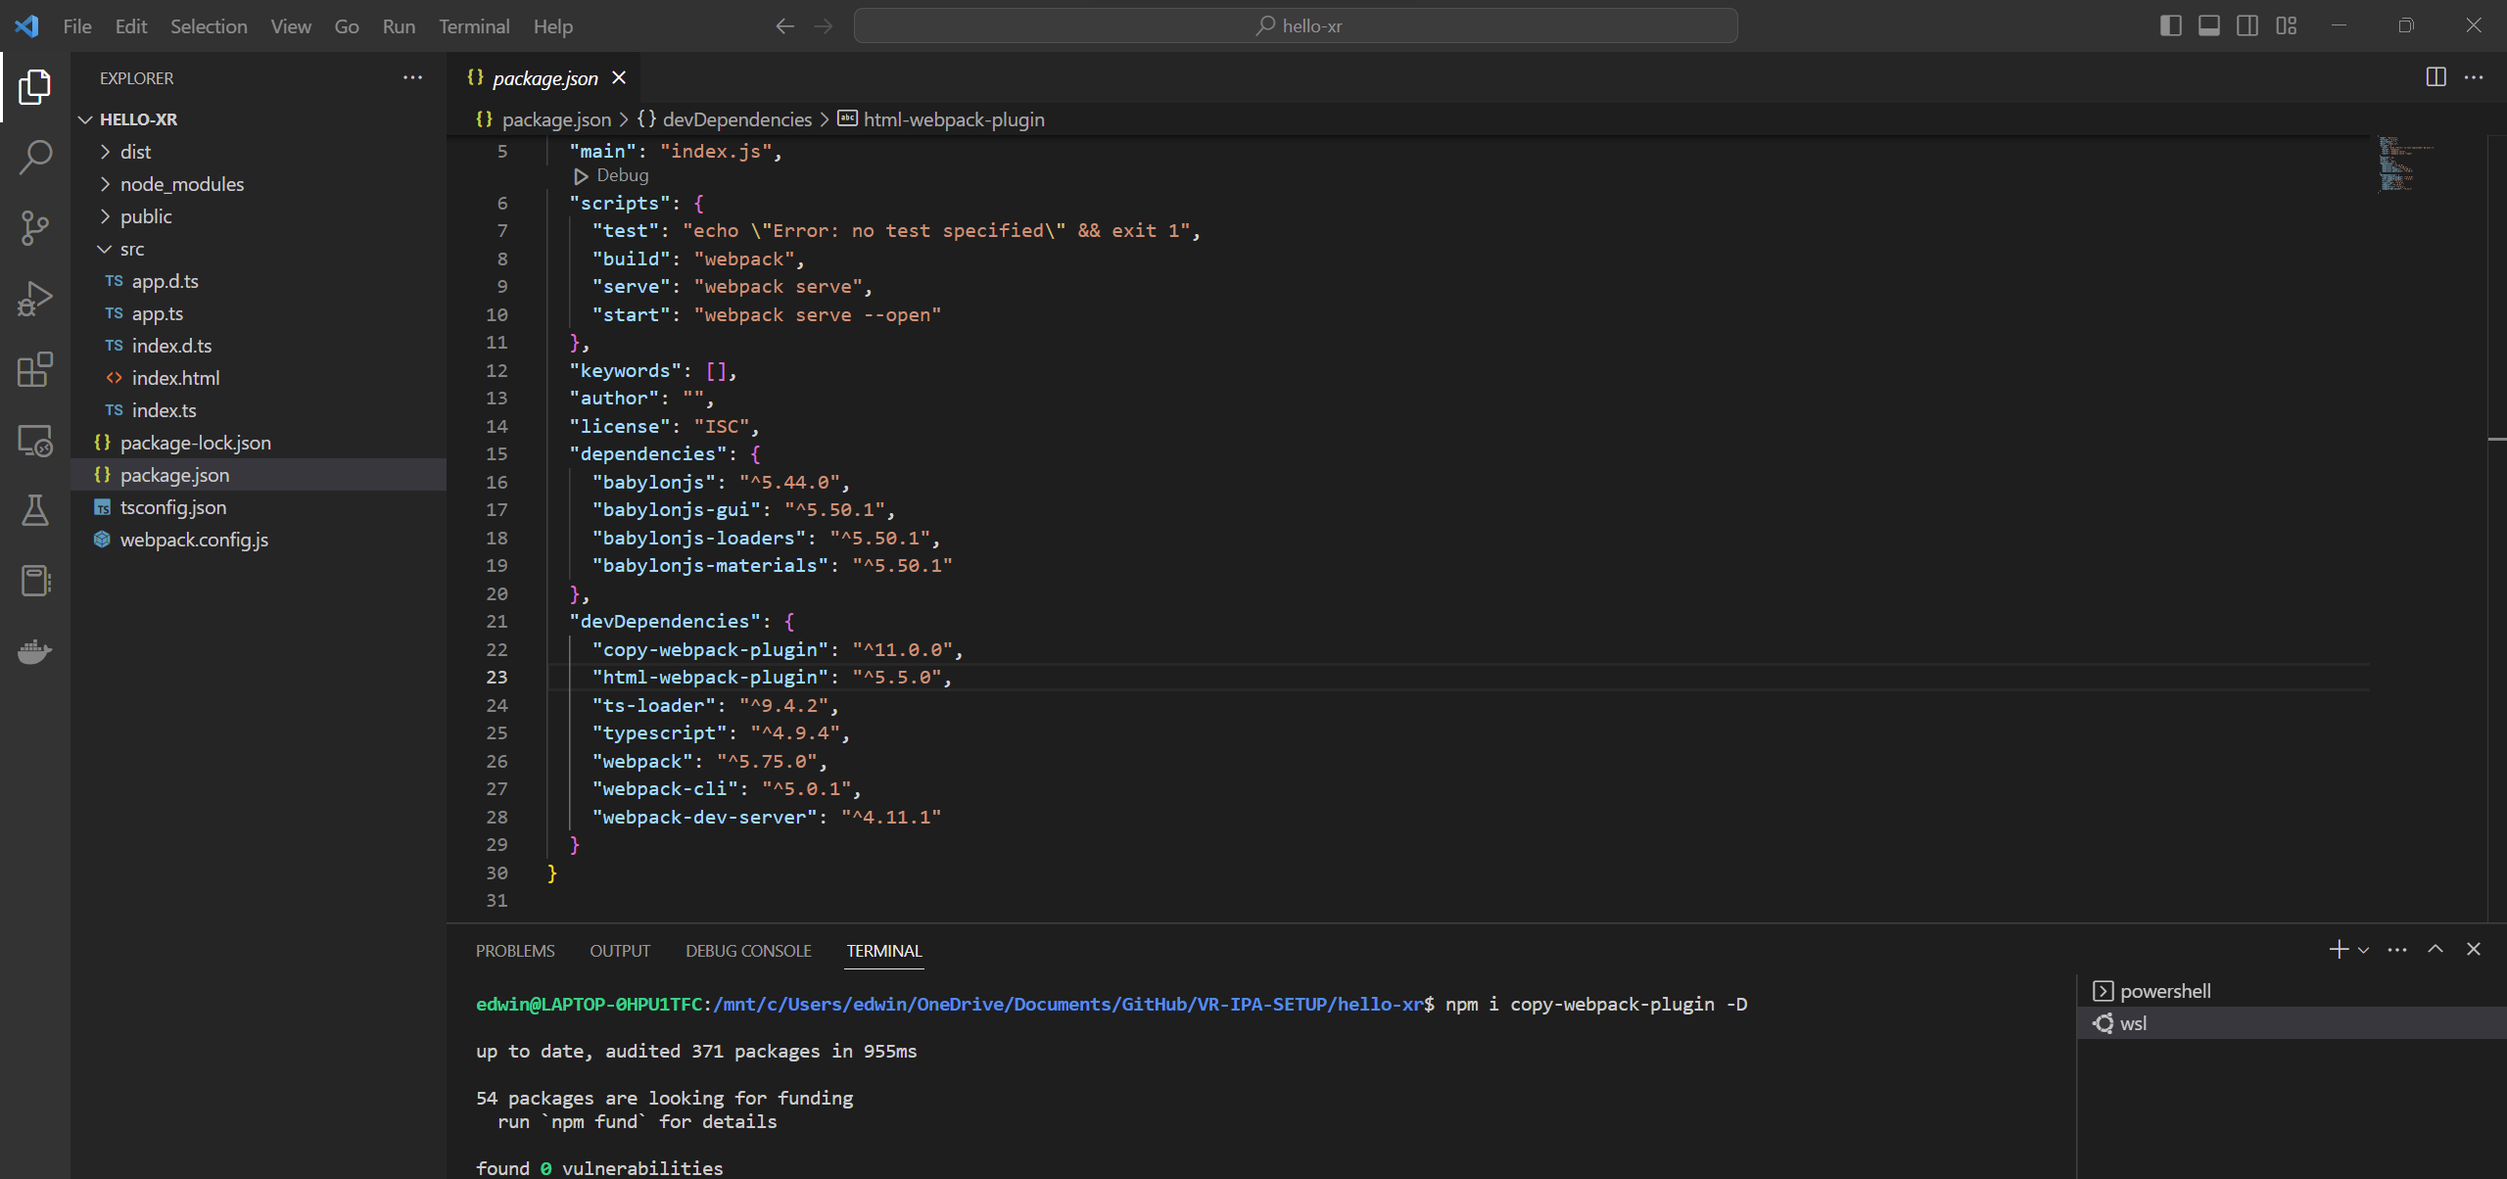

**webpack.json**

Add the following codes:

const CopyPlugin = require('copy-webpack-plugin')

Here:

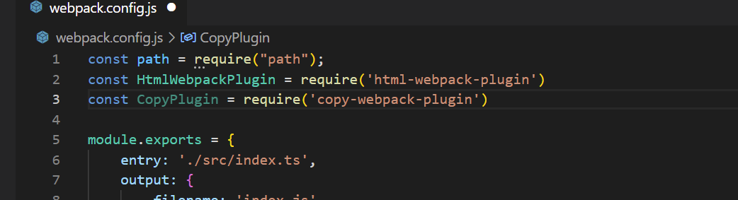

Add the following codes:

new CopyPlugin({

            patterns: [

                { from: path.resolve(__dirname, 'public')}

            ]

        }),

Here:

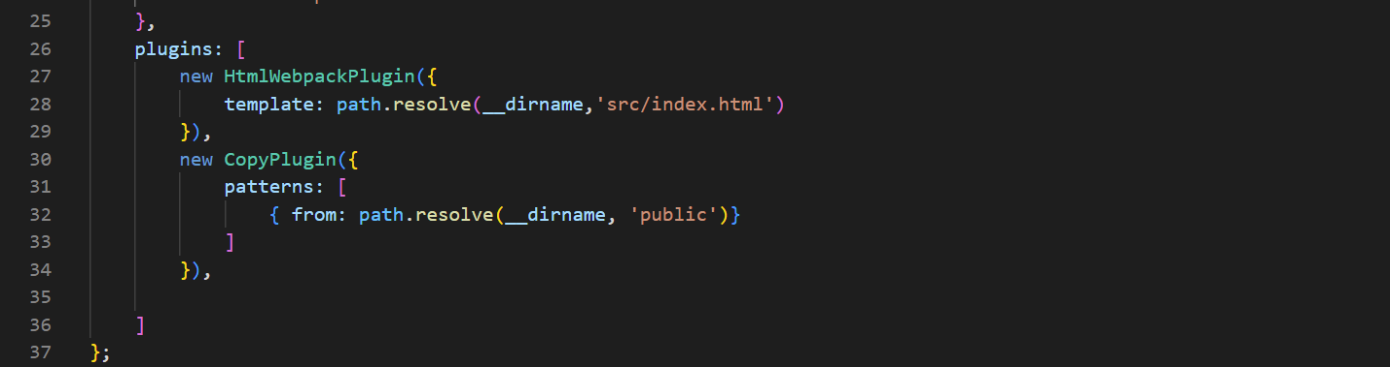

Enter the following commands in WSL (to Rebuild the project):

npm run build

You should be able to see your assets folder from your public folder copied to your dist folder.

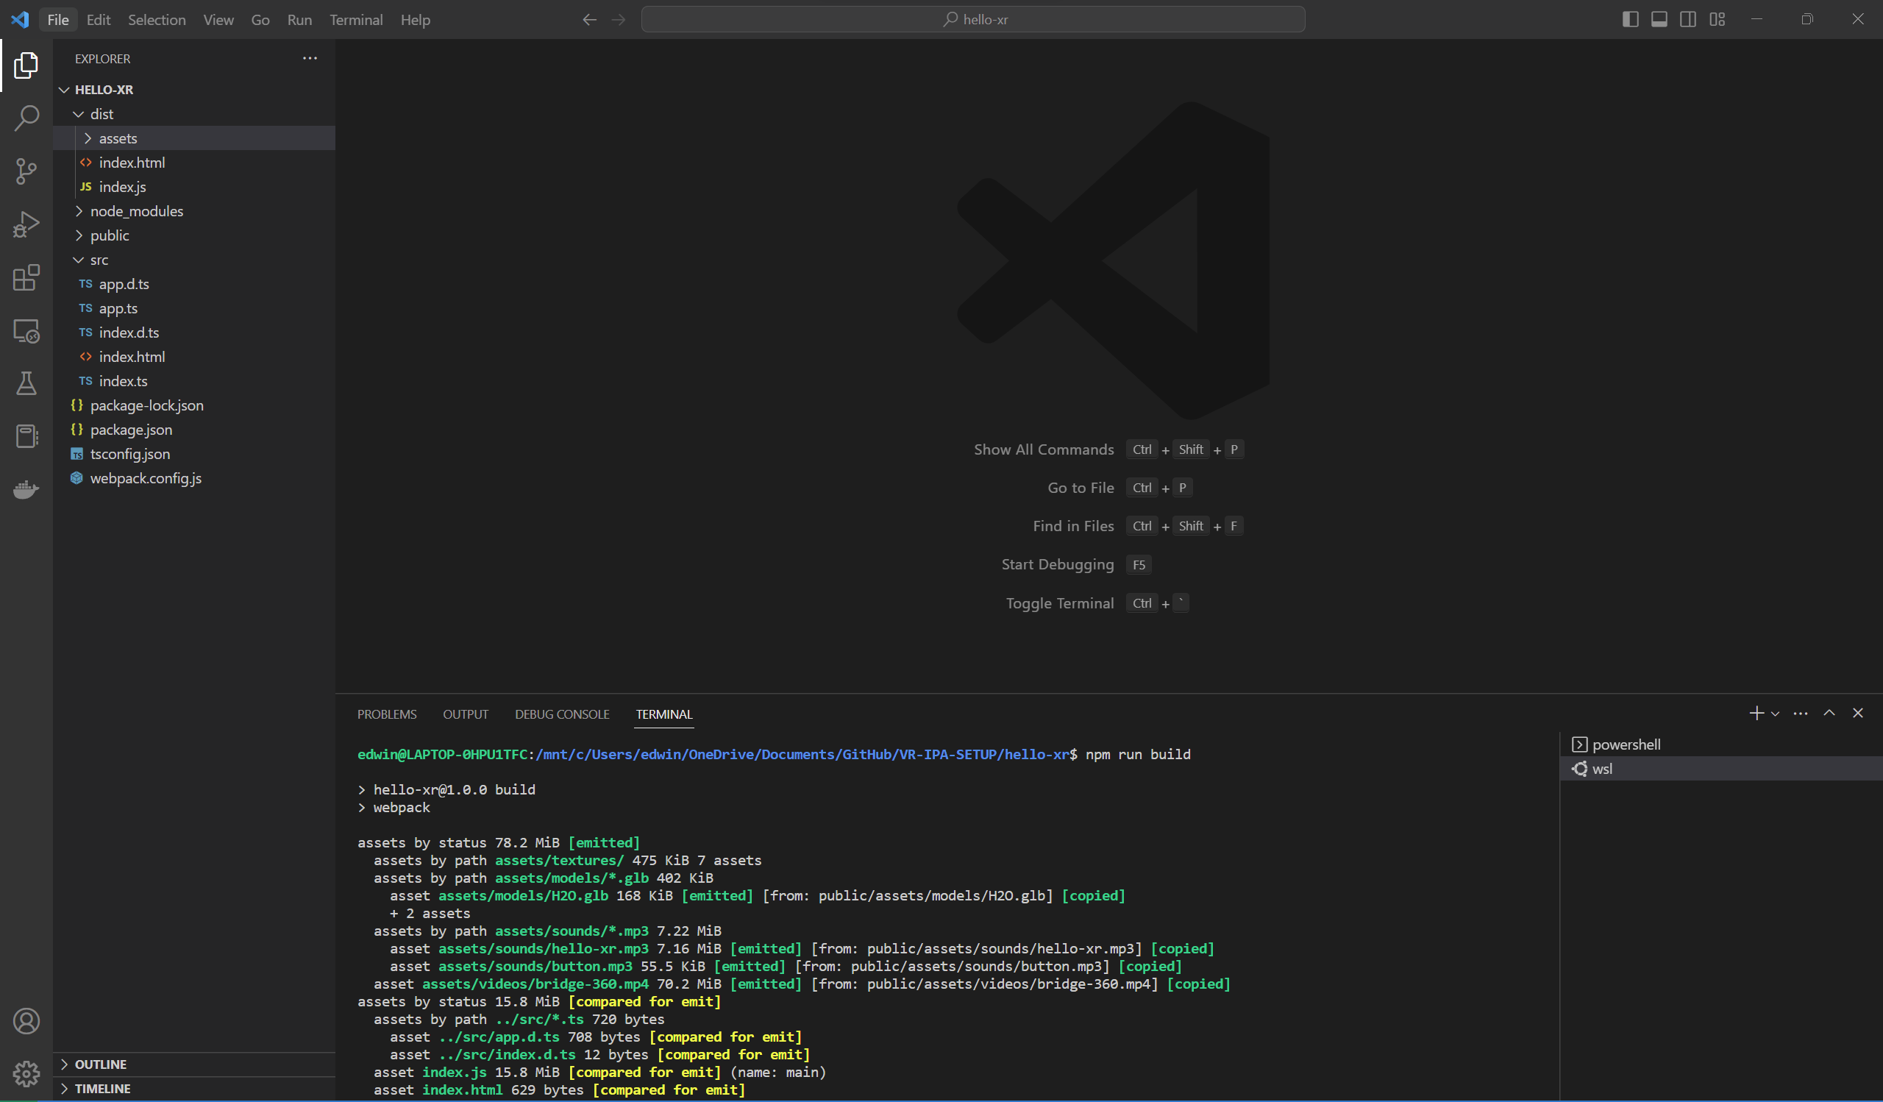

## Deploying to Production Server (instead of Dev Server)

Enter the following commands in WSL:

cd dist

python3 -m http.server

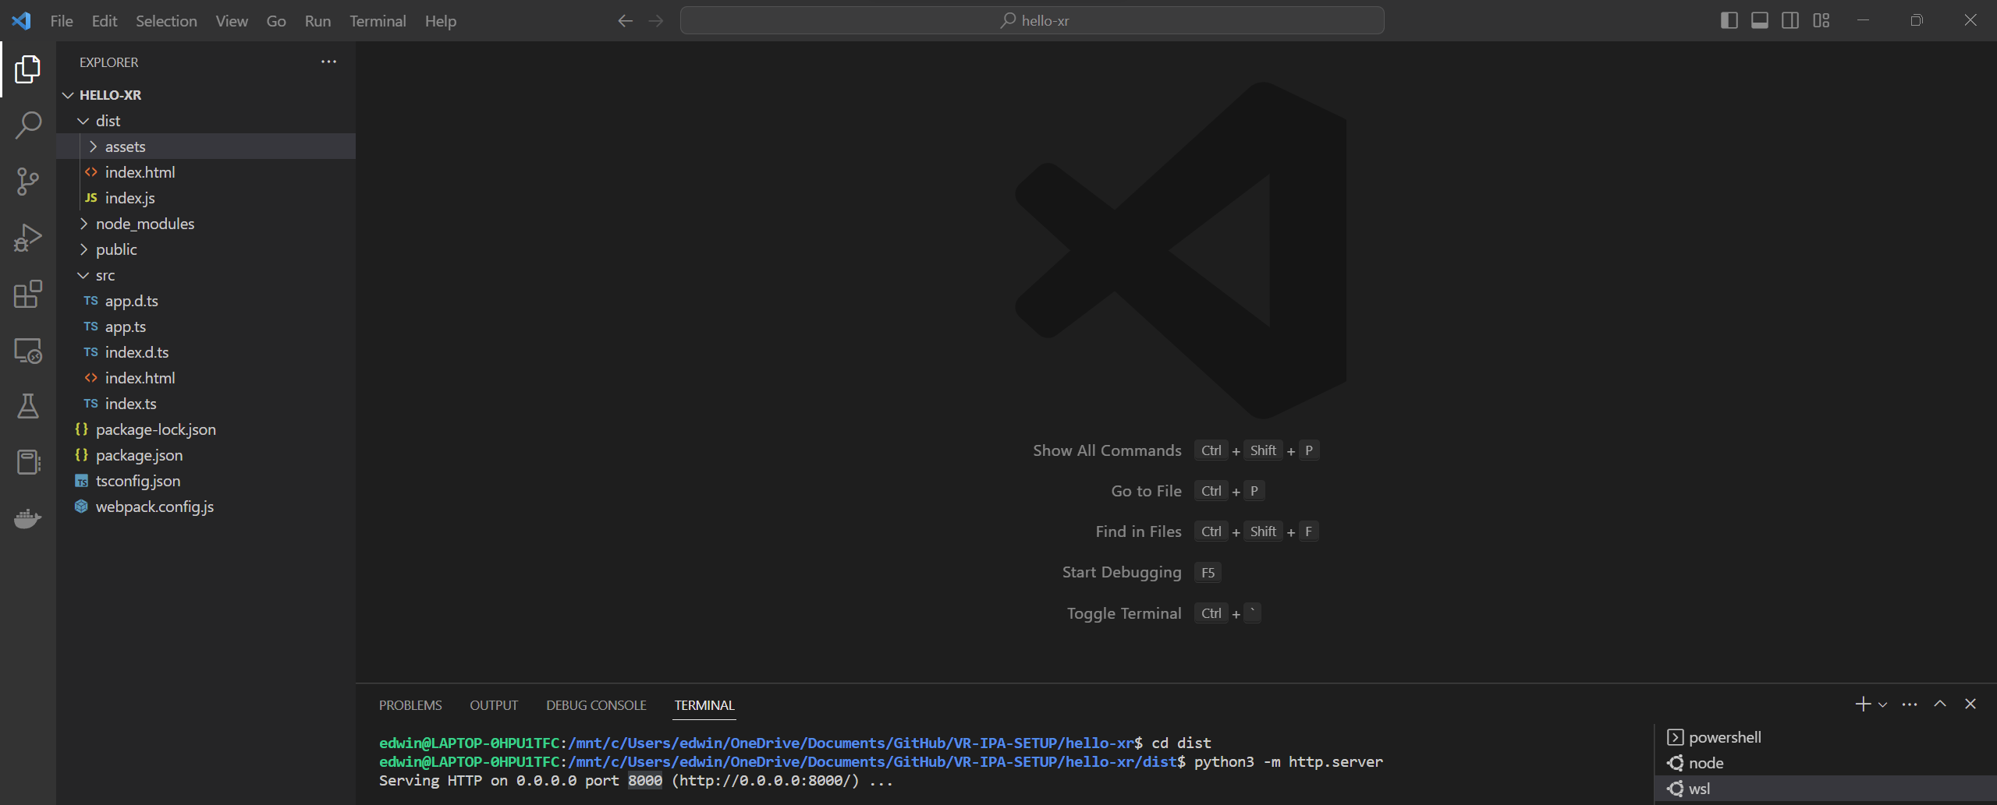

Go to localhost:8000 in your chrome browser.

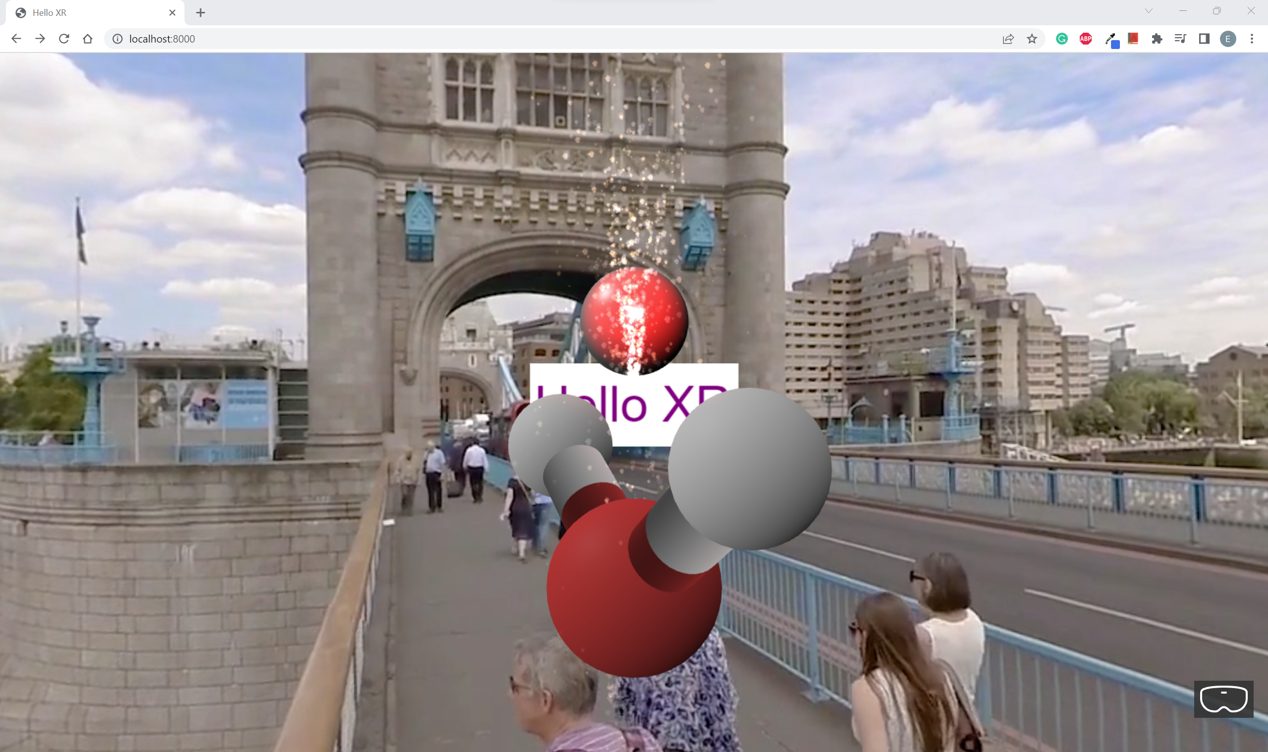

You should be able to see the Web App working fine on the production server.

## Refactoring codes

**tsconfig.json**

Comment out the following codes:

//"declaration": true,

Here:

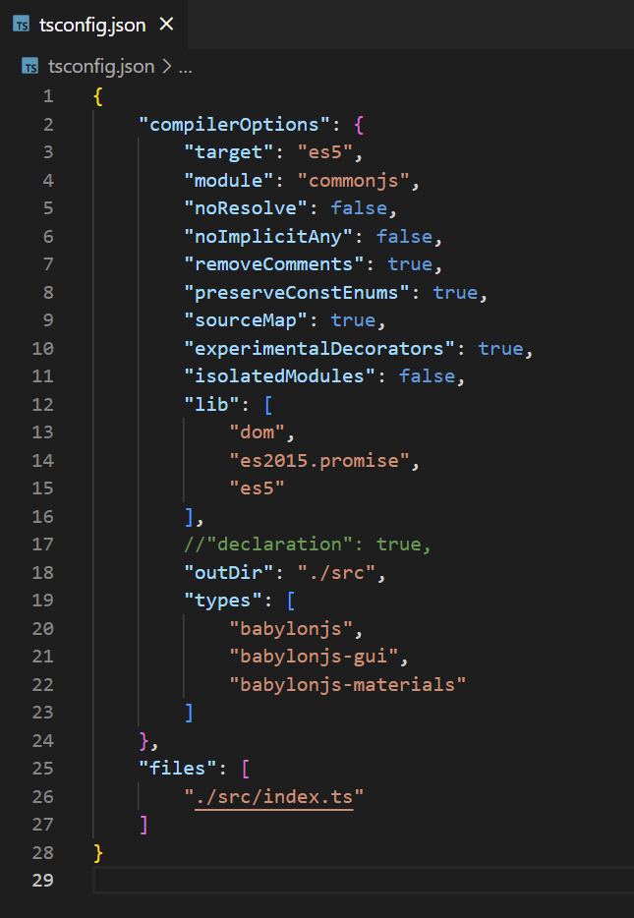

**app.ts**

Under createScene():

Comment out the following codes:

//this.createVideoSkyDome(scene);

//this.addSounds(scene)

Change this code to:

sphere.position.y = -0.5

Change these codes to:

scene.createDefaultCameraOrLight()

//this.createCamera(scene)

//this.createLights(scene)

*Component based architecture*

### Text Component

Enter the following commands in WSL:

cd src

mkdir -p components/meshes

cd components/meshes

touch index.ts

touch text-plane.ts

You should be able to see "components\meshes" folders added to your "src" folder.

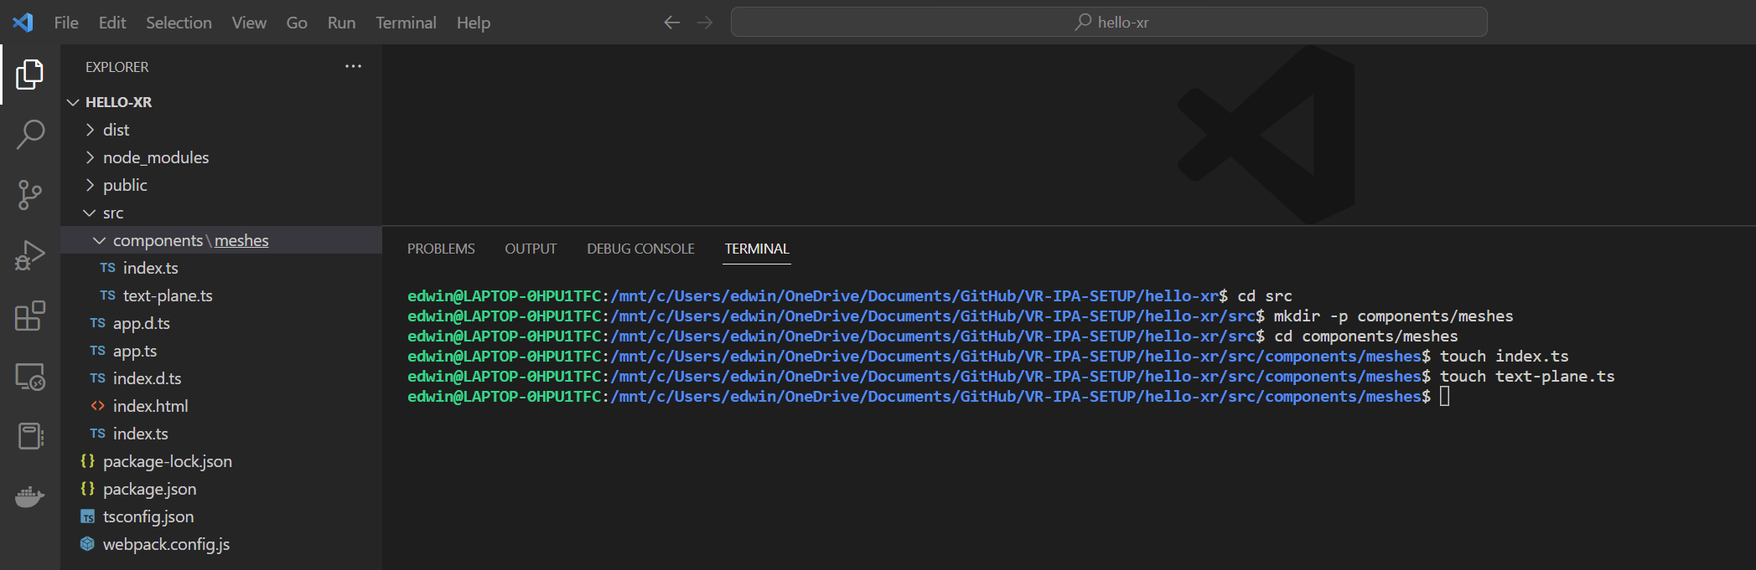

Go to **components\meshes\index.ts** and add the following codes:

export * from './text-plane'

Go to **components\meshes\text-plane.ts** and add the following codes:

import { Mesh, MeshBuilder, Scene } from "babylonjs";

import { AdvancedDynamicTexture, TextBlock } from "babylonjs-gui";

export class TextPlane {

  public mesh: Mesh

  public textBlock: TextBlock;

  constructor(

    name: string,

    width: number,

    height: number,

    x: number,

    y: number,

    z: number,

    text: string,

    backgroundColor: string,

    textColor: string,

    fontSize: number,

    scene: Scene

  ) {

    const textPlane = MeshBuilder.CreatePlane(name + " text plane", {

      width: width,

      height: height,

    });

    textPlane.position.set(x, y, z);

    const planeTexture = AdvancedDynamicTexture.CreateForMesh(

      textPlane,

      width * 100,

      height * 100,

      false

    );

    planeTexture.background = backgroundColor;

    const planeText = new TextBlock(name + " plane text");

    planeText.text = text;

    planeText.color = textColor;

    planeText.fontSize = fontSize;

    planeTexture.addControl(planeText);

    this.mesh = textPlane

    this.textBlock = planeText

  }

}

**app.ts**

Add the following codes:

import { TextPlane } from "./components/meshes"

Here:

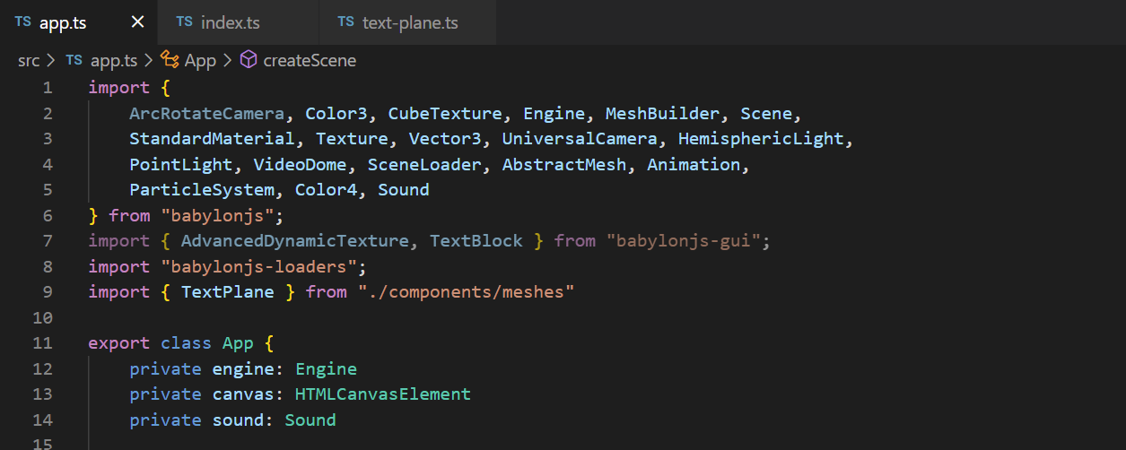

Replace CreateText(scene:Scene) with the following codes:

createText(scene:Scene)

    {

        const helloPlane = new TextPlane(

            "hello plane",

            3,

            1,

            0,

            2,

            5,

            "Hello XR",

            "white",

            "purple",

            60,

            scene

        )

        helloPlane.textBlock.onPointerUpObservable.add(evtData => {

            alert('Hello Text at: \n x: ' + evtData.x + ' y:' + evtData.y)

        })

        helloPlane.textBlock.onPointerDownObservable.add(() => {

            this.sound.play()

        })

    }

Here:

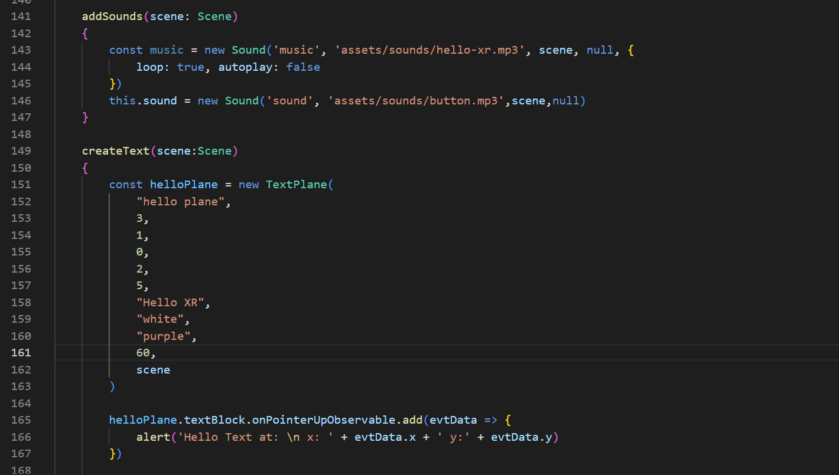

### Mesh Component

Enter the following commands in WSL:

touch hello-mesh.ts

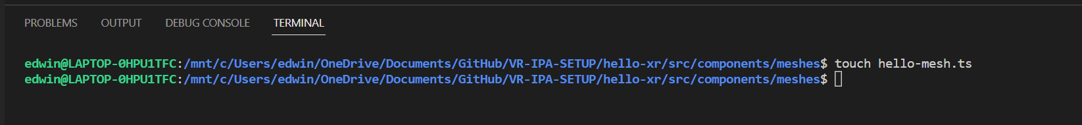

You should be able to see "hello-mesh.ts" file added to your "components\meshes" folder.

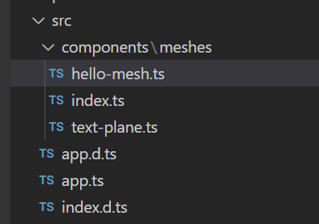

**app.ts**

Change these codes under createScene() to:

//simple sphere

        const sphere = MeshBuilder.CreateSphere('sphere', { diameter: 1.3 }, scene)

        sphere.position.y = -0.5

        sphere.position.z = 5

        //hello sphere

        const helloSphere = new HelloSphere("hello sphere", {diameter: 1}, scene)

        helloSphere.position.set(0, 1, 5)

Go to **components\meshes\index.ts** and add the following codes:

export * from './hello-mesh'

Go to **components\meshes\hello-mesh.ts** and add the following codes:

import {

  AbstractMesh,

  Mesh,

  MeshBuilder,

  Scene,

  StandardMaterial,

} from "babylonjs";

import { TextPlane } from "./text-plane";

export interface HelloMesh {

  scene: Scene;

  mesh: Mesh;

  label: TextPlane;

}

export class HelloSphere extends AbstractMesh implements HelloMesh {

  scene: Scene;

  mesh: Mesh;

  label: TextPlane;

  constructor(name: string, options: { diameter: number }, scene: Scene) {

    super(name, scene);

    this.scene = scene;

    this.mesh = MeshBuilder.CreateSphere("hello sphere mesh", options, scene);

    this.mesh.material = new StandardMaterial("hello sphere material", scene);

    this.addChild(this.mesh);

    this.label = new TextPlane(

      "hello sphere label",

      1.5,

      1,

      0,

      options.diameter / 2 + 0.2,

      0,

      "hello sphere",

      "purple",

      "white",

      25,

      scene

    );

    this.addChild(this.label.mesh);

  }

}

**Check**

You should see 2 Spheres rendered in your web app.

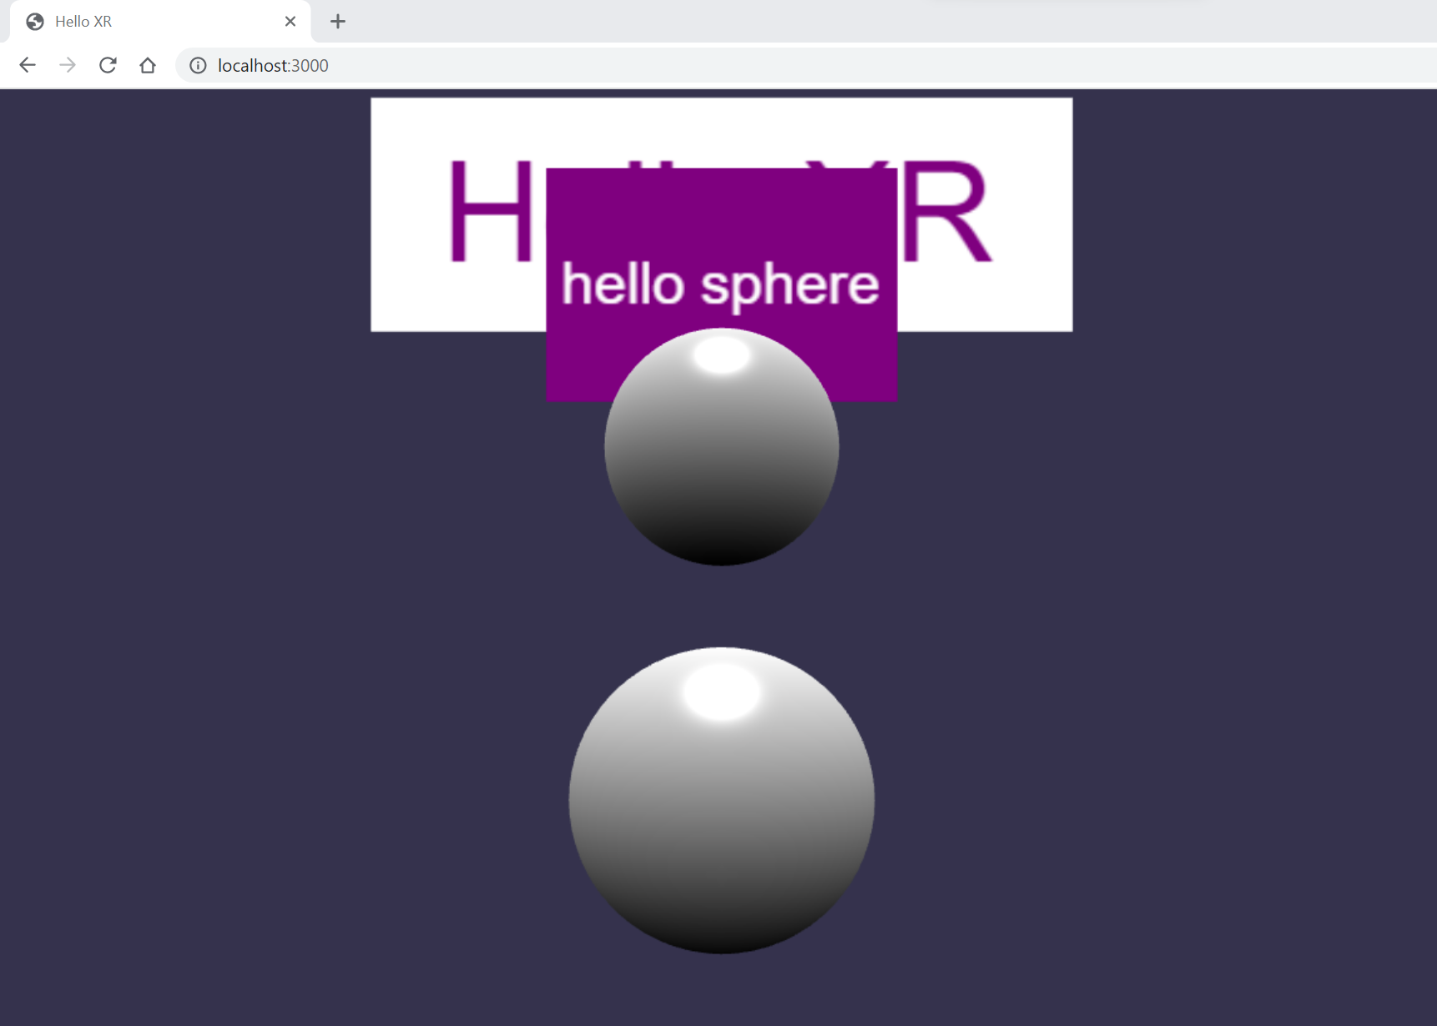

## Creating Ground Plane

**app.ts**

Add the following codes:

 //ground

    const groundMaterial = new StandardMaterial("ground material",  scene)

    groundMaterial.backFaceCulling = true

    groundMaterial.diffuseTexture = new Texture('assets/textures/grass.png', scene)

    const ground = MeshBuilder.CreateGround("ground", {width: 12, height: 12}, scene)

    ground.material = groundMaterial

    ground.position.set(0, -1, 8)

Here:

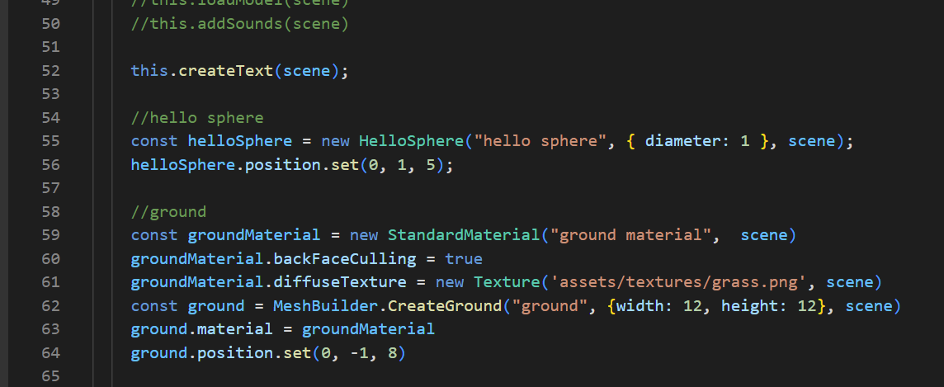

Change these codes to:

scene.createDefaultCameraOrLight(false, true, true)

## Interactions (Moving Sphere)

**app.ts**

Add the following codes:

 //interactions

    //use behaviors

    const pointerDragBehavior = new PointerDragBehavior({

      dragPlaneNormal: Vector3.Up(),

    });

    sphere.addBehavior(pointerDragBehavior);

Here:

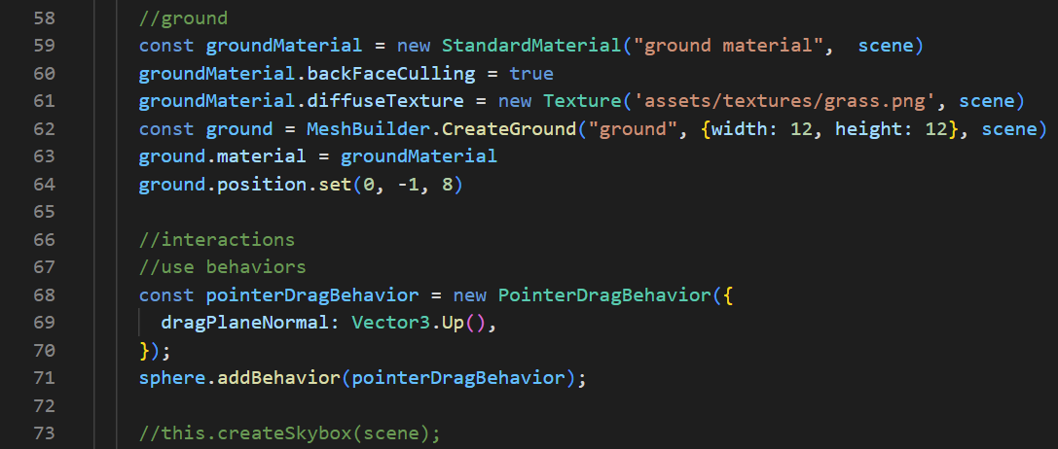

**Check**

You should be able to move the Sphere closest to you by Left/Middle/Right clicking and dragging the Sphere around.

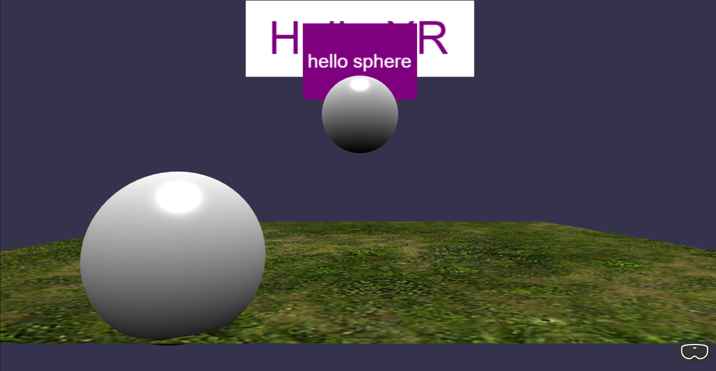

## Observables (Console log)

**app.ts**

Add the following codes:

pointerDragBehavior.onDragStartObservable.add(evtData=>{

      console.log("drag start: pointer id -" + pointerDragBehavior,

      evtData.pointerId)

      console.log(evtData)

    })

Here:

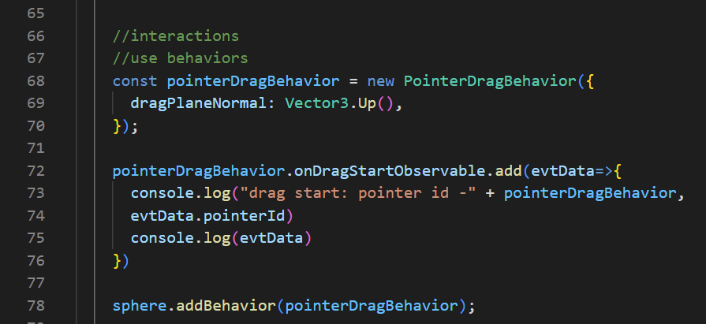

**Check**

You should be able to see “drag start: …” printed in the Console tab whenever you select and drag the Sphere around.

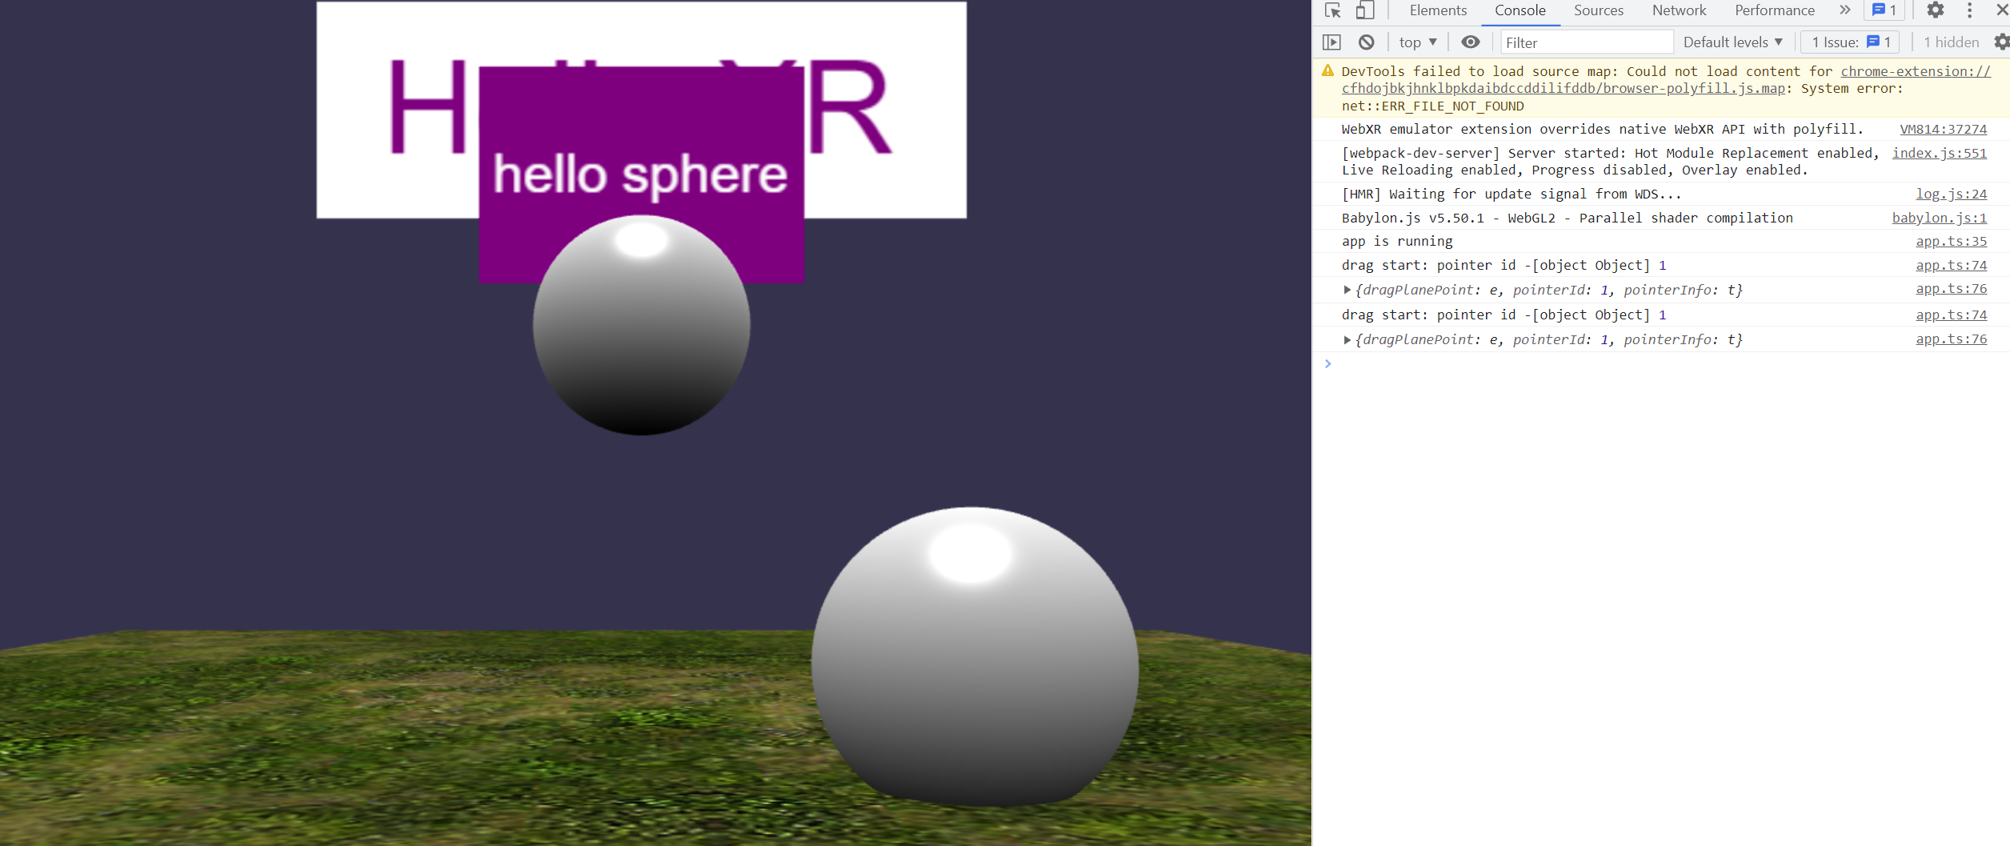

**app.ts**

Add the following codes:

helloSphere.sayHello("this a test.")

Here:

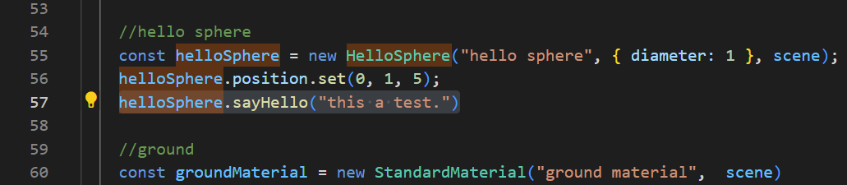

**components\meshes\hello-mesh.ts**

Add the following codes:

sayHello(message?: string): void

Here:

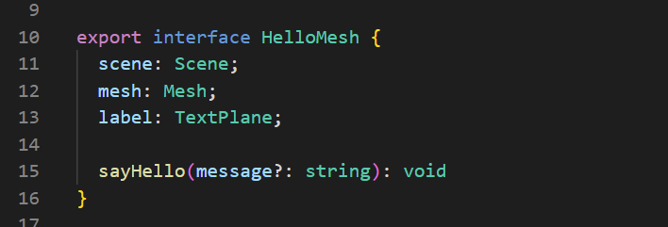

Add the following codes:

 sayHello(message?: string): void{

    console.log("message from hello sphere: " + message)

  }

Here:

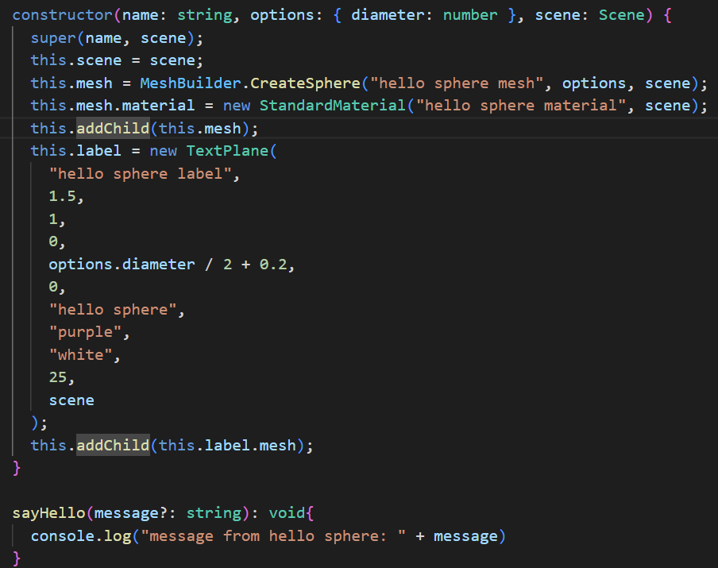

**Check**

You should be able to see “message from hello sphere: this a test.” printed in the Console tab when you start the web app.

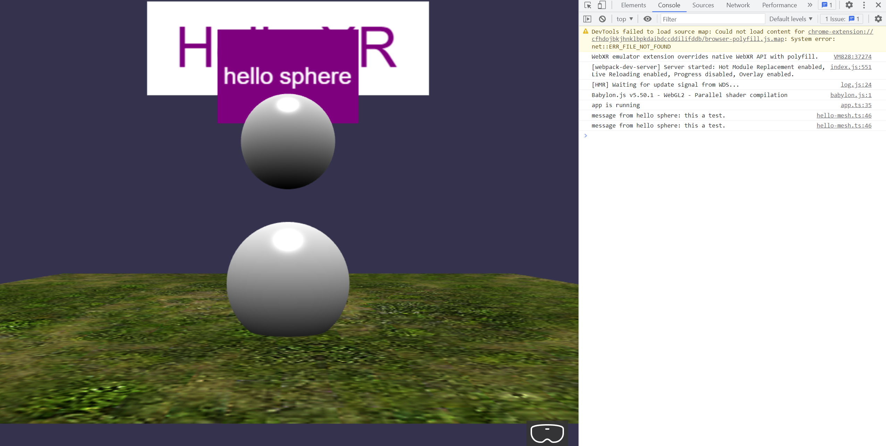

## Action Behaviours

### Mouse Input

**components\meshes\hello-mesh.ts**

Add the following codes:

this.initActions();

Here:

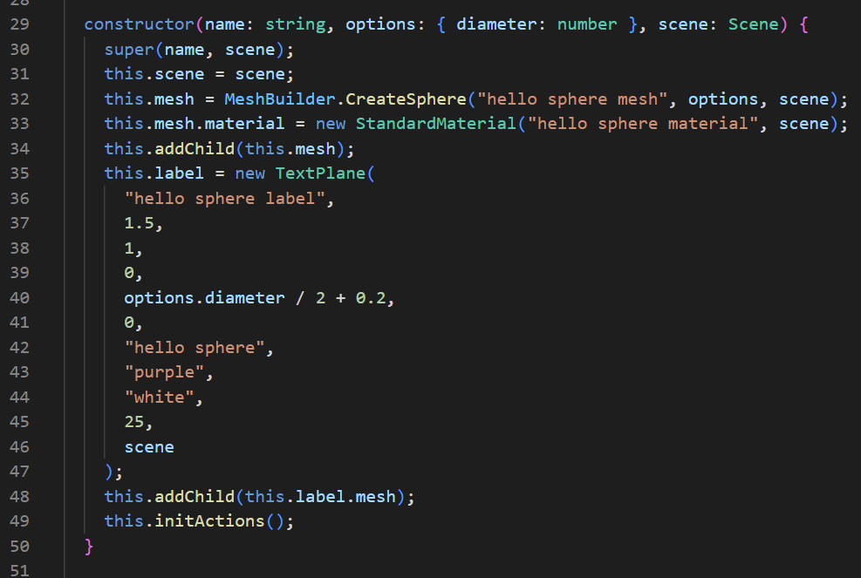

Add the following codes:

private initActions() {

    const actionManager = (this.actionManager = new ActionManager(this.scene));

    actionManager.isRecursive = true;

    const light = this.scene.getLightById("default light");

    //Switch ON/OFF lights

    actionManager

      .registerAction(

        new InterpolateValueAction(

          ActionManager.OnPickDownTrigger,

          light,

          "diffuse",

          Color3.Black(),

          1000

        )

      )

      .then(

        new InterpolateValueAction(

          ActionManager.OnPickDownTrigger,

          light,

          "diffuse",

          Color3.White(),

          1000

        )

      );

    //Scale up sphere

    actionManager.registerAction(

      new InterpolateValueAction(

        ActionManager.OnPickDownTrigger,

        this,

        "scaling",

        new Vector3(2, 2, 2),

        1000,

        new PredicateCondition(actionManager, () => {

          return light.diffuse.equals(Color3.Black());

        })

      )

    );

    //Collision

    const otherMesh = this.scene.getMeshById("sphere");

    actionManager.registerAction(

      new SetValueAction(

        {

          trigger: ActionManager.OnIntersectionEnterTrigger,

          parameter: {

            mesh: otherMesh,

            usePreciseIntersection: true,

          },

        },

        this.mesh.material,

        "wireframe",

        true

      )

    );

  }

Here: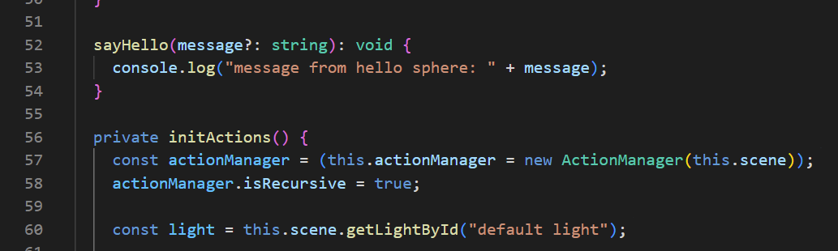

**app.ts**

Add the following codes:

const helloSphereDragBehavior = new PointerDragBehavior({

      dragPlaneNormal: Vector3.Backward(),

    });

    helloSphere.addBehavior(helloSphereDragBehavior);

Here:

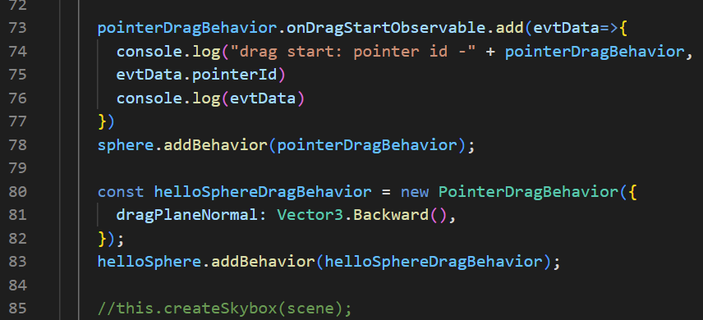

**Check**

When you click on the “helloSphere” Object, you should be able to see the surroundings turning black.

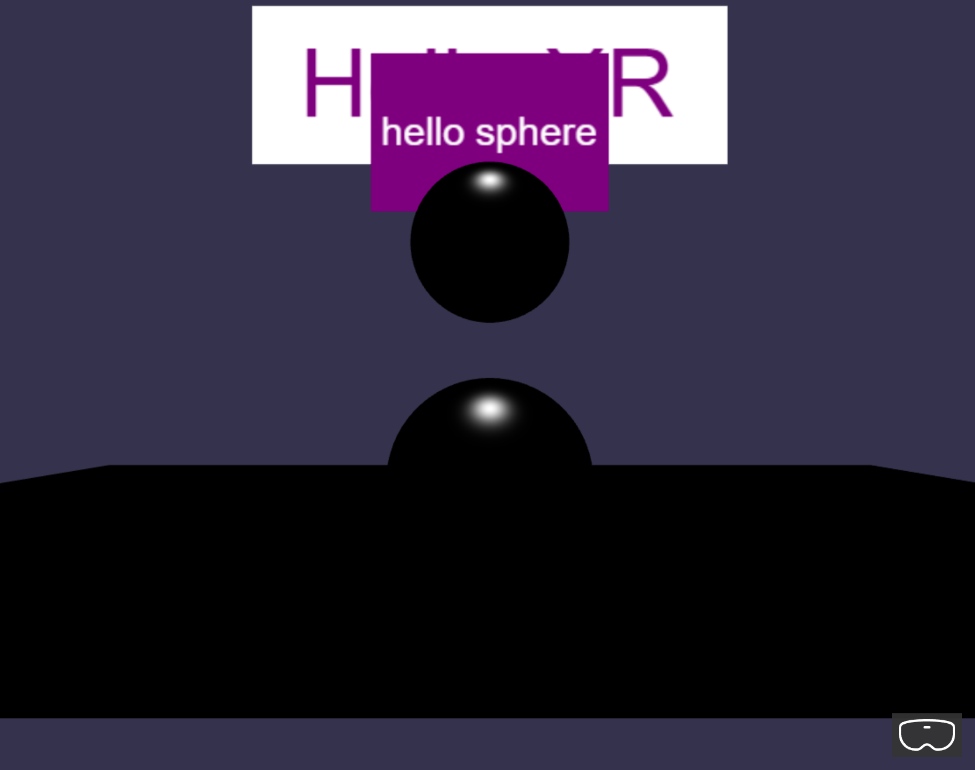

When you click on the “helloSphere” Object again, the lights will turn back on, and the “helloSphere” Object will begin to gradually expand to 2 times its original size.

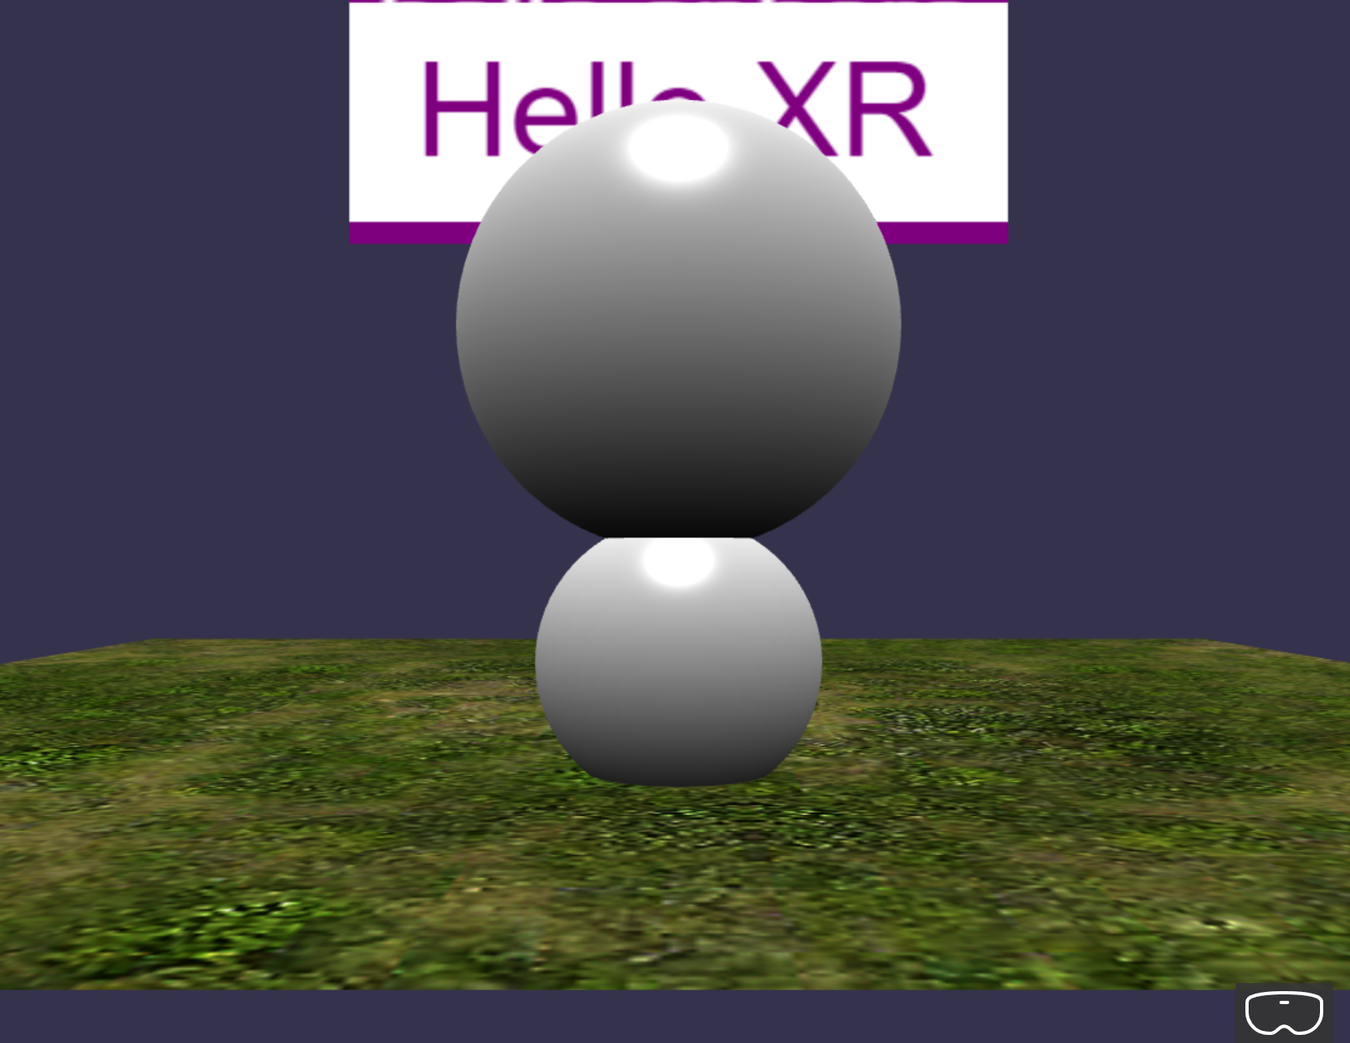

When you drag the “helloSphere” Object to collide with the “sphere” Object, the “helloSphere” Object will turn into a wireframe Sphere.

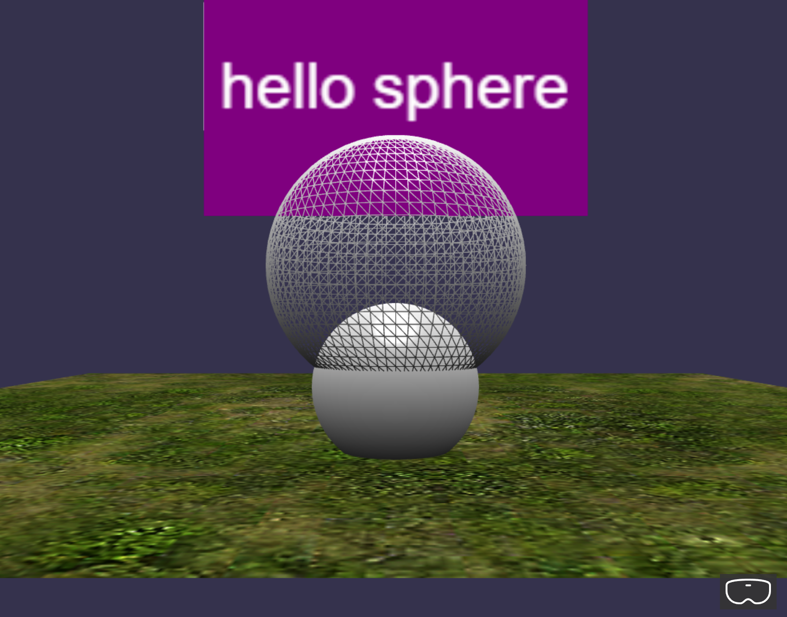

### Keyboard Input

**app.ts**

Add the following codes:

scene.actionManager = new ActionManager(scene)

Here: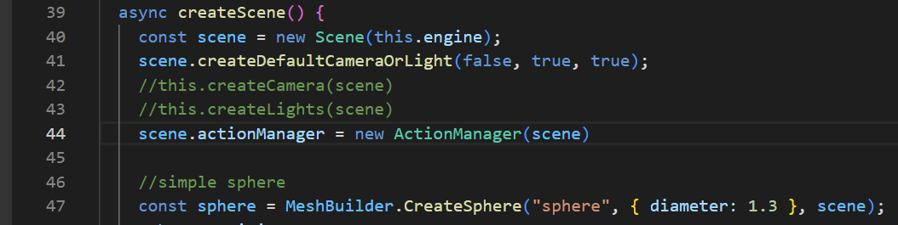

**components\meshes\hello-mesh.ts**

Add the following codes:

//Reset sphere

    this.scene.actionManager.registerAction(

      new ExecuteCodeAction(

        {

          trigger: ActionManager.OnKeyUpTrigger,

          parameter: "r",

        },

        () => {

          this.scaling.setAll(1);

          this.mesh.material.wireframe = false;

          console.log("r was pressed: reset " + this.name);

        }

      )

    );

Here:

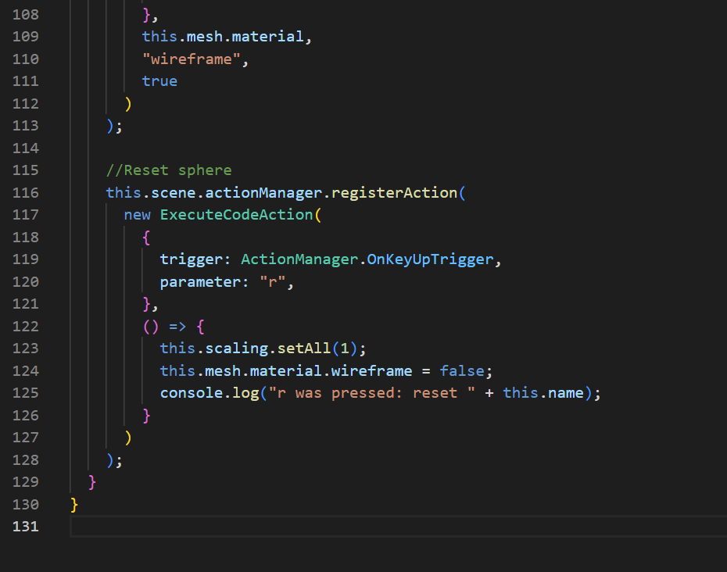

**Check**

When you press the “R” Key, the previous effects that the “helloSphere” Object is having will reset back to its original state.

Before:

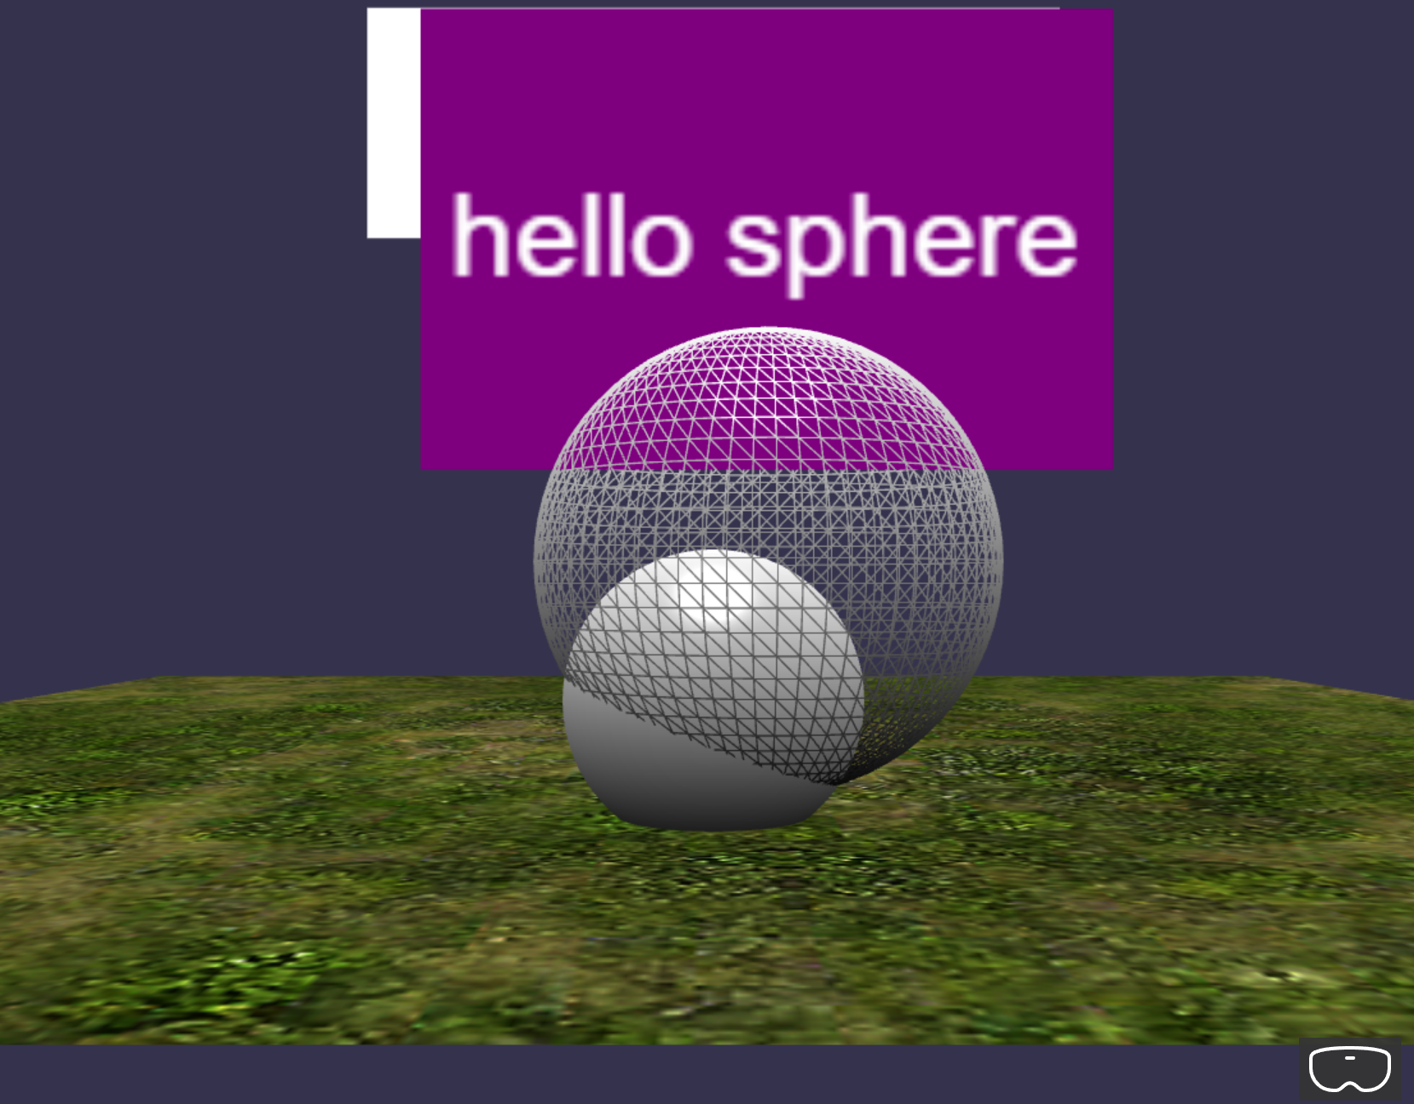

After:  
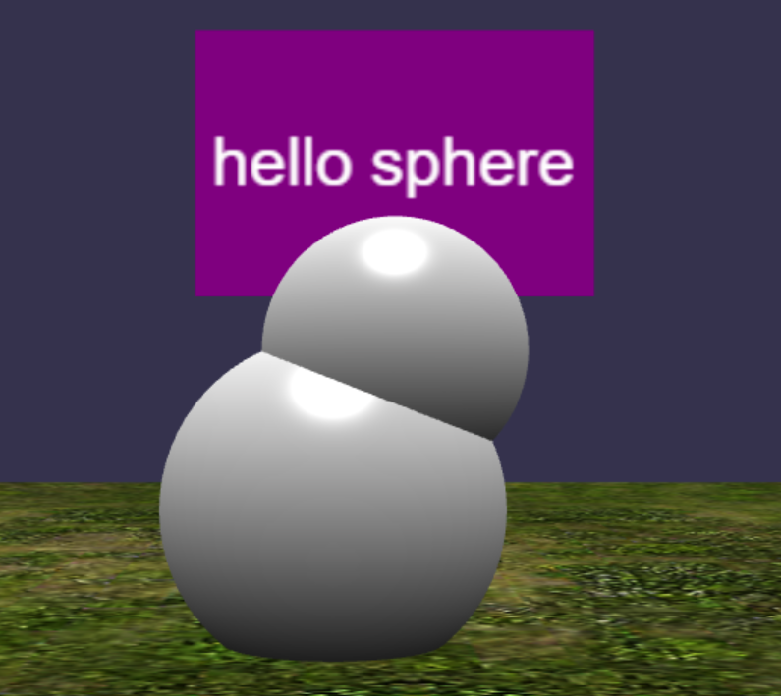

## Observables (Collision)

**app.ts**

Add the following codes:

//use observables (@ Can be shifted to hello-mesh.ts class)

    //1. create an observable for detecting intersections

    const onIntersectObservable = new Observable<boolean>()

    scene.registerBeforeRender(function(){

      const isIntersecting = sphere.intersectsMesh(helloSphere, true, true)

      onIntersectObservable.notifyObservers(isIntersecting)

    })

    helloSphere.onInterectObservable = onIntersectObservable

    const redColor = Color3.Red()

    const whiteColor = Color3.White()

    helloSphere.onInterectObservable.add(isIntersecting => {

      const material = helloSphere.mesh.material as StandardMaterial

      const isRed = material.diffuseColor === redColor

      if(isIntersecting && !isRed)

      {

        material.diffuseColor = redColor

      }

      else if(!isIntersecting && isRed)

      {

        material.diffuseColor = whiteColor

      }

    })

Here:

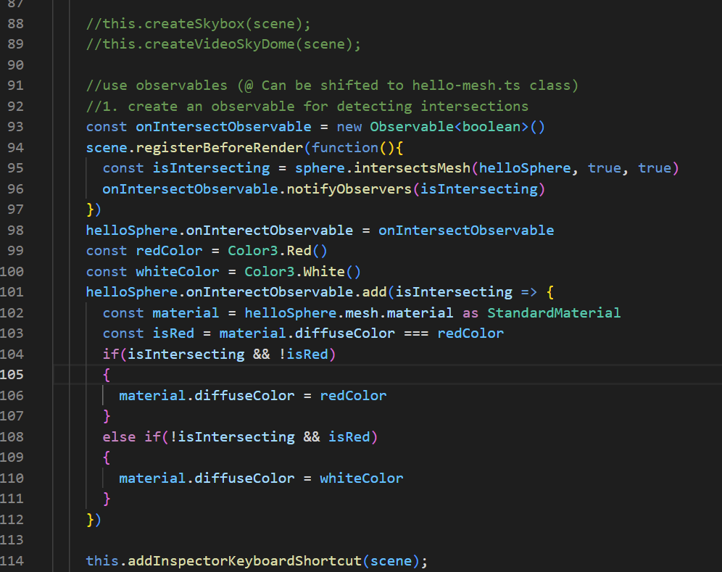

**components\meshes\hello-mesh.ts**

Add the following codes:

onInterectObservable: Observable<boolean>

Here:

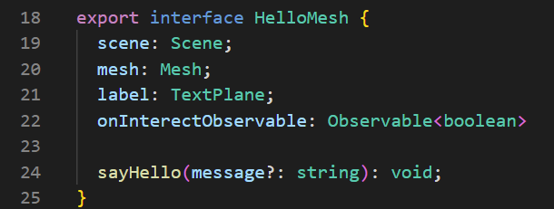

Here:

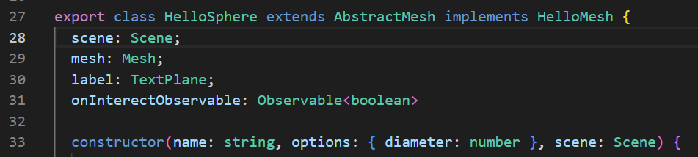

**Check**

When you drag the “helloSphere” Object to collide with the “sphere” Object, the “helloSphere” Object will turn into a Red wireframe Sphere.

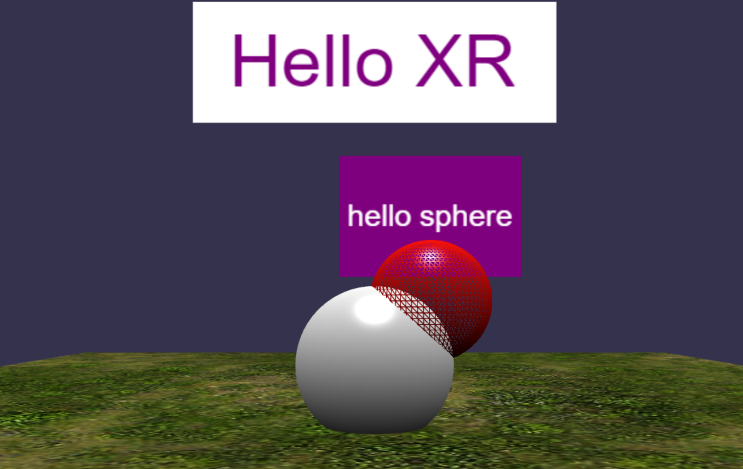

## Observables (Collision checking distance)

**app.ts**

Add the following codes:

//2. create an observable for check distance

    const onDistanceChangeObservable = new Observable<number>();

    let previousState: number = null;

    scene.onBeforeRenderObservable.add(() => {

      const currentState = Vector3.Distance(

        sphere.position,

        helloSphere.position

      );

      if (currentState !== previousState) {

        console.log("distance updated!");

        previousState = currentState;

        onDistanceChangeObservable.notifyObservers(currentState);

      }

    });

    helloSphere.onDistanceChangeObservable = onDistanceChangeObservable;

    const blueColor = Color3.Blue();

    helloSphere.onDistanceChangeObservable.add((distance) => {

      const isCloseEnough = distance <= 1.2;

      const material = helloSphere.mesh.material as StandardMaterial;

      const isBlue = material.diffuseColor === blueColor;

      const isRed = material.diffuseColor === redColor;

      if (isCloseEnough && !isBlue && !isRed) {

        material.diffuseColor = blueColor;

      } else if (!isCloseEnough && isBlue) {

        material.diffuseColor = whiteColor;

      }

    });

Here:

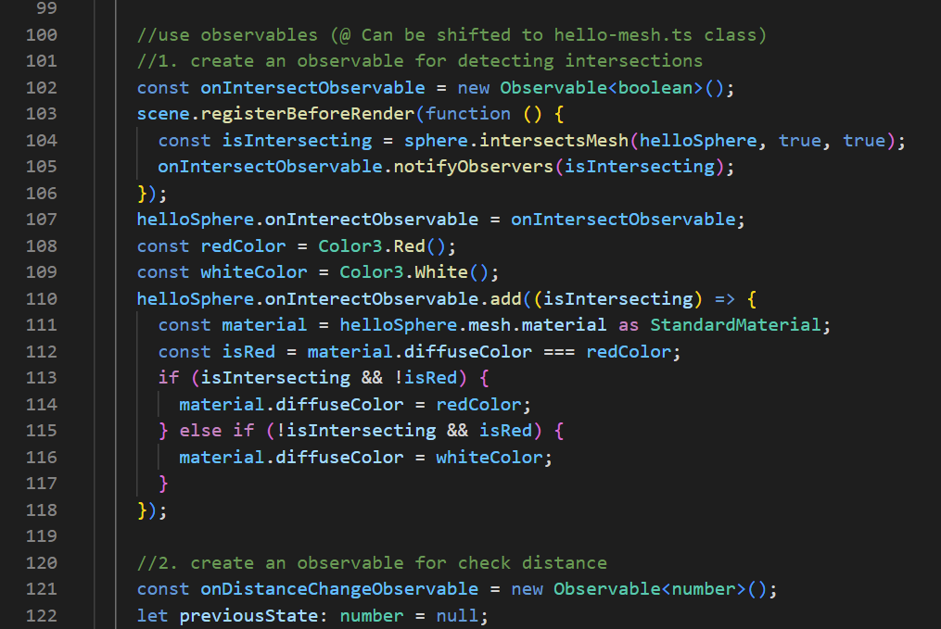

**components\meshes\hello-mesh.ts**

Add the following codes:

onDistanceChangeObservable: Observable<number>

Here:

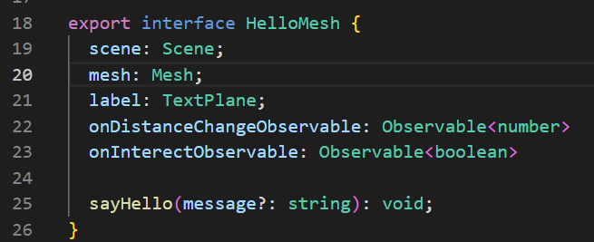

Here:

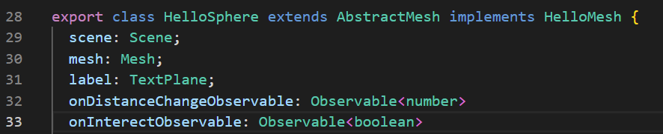

**Check**

When you drag the “helloSphere” Object to collide with the “sphere” Object, the “helloSphere” Object will first turn into a Blue wireframe Sphere.

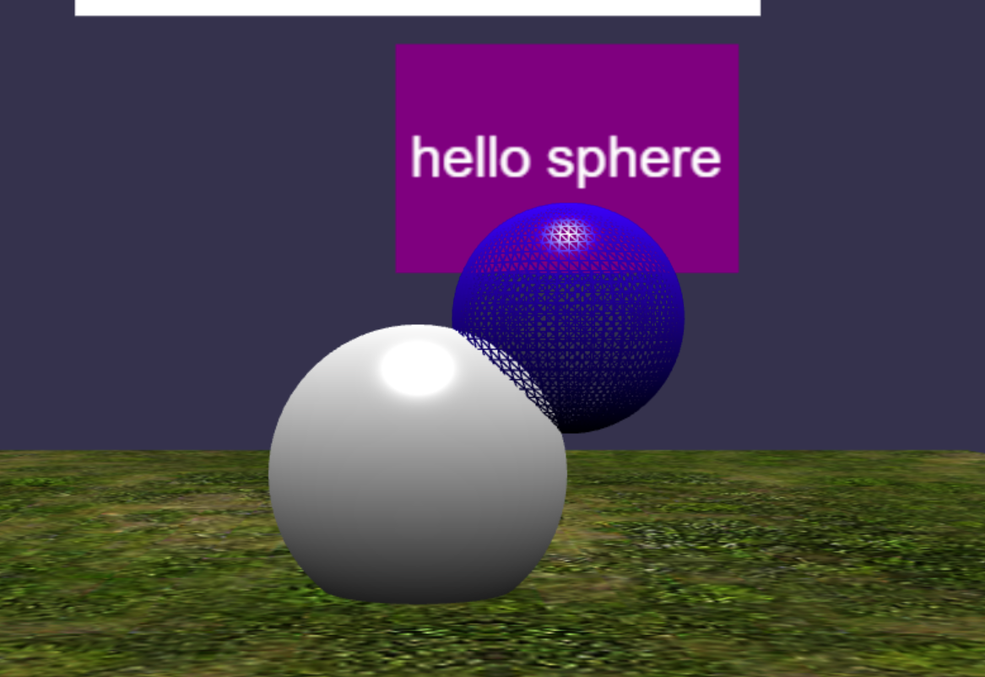

Then it will turn into a Red wireframe Sphere when the collision is further in.

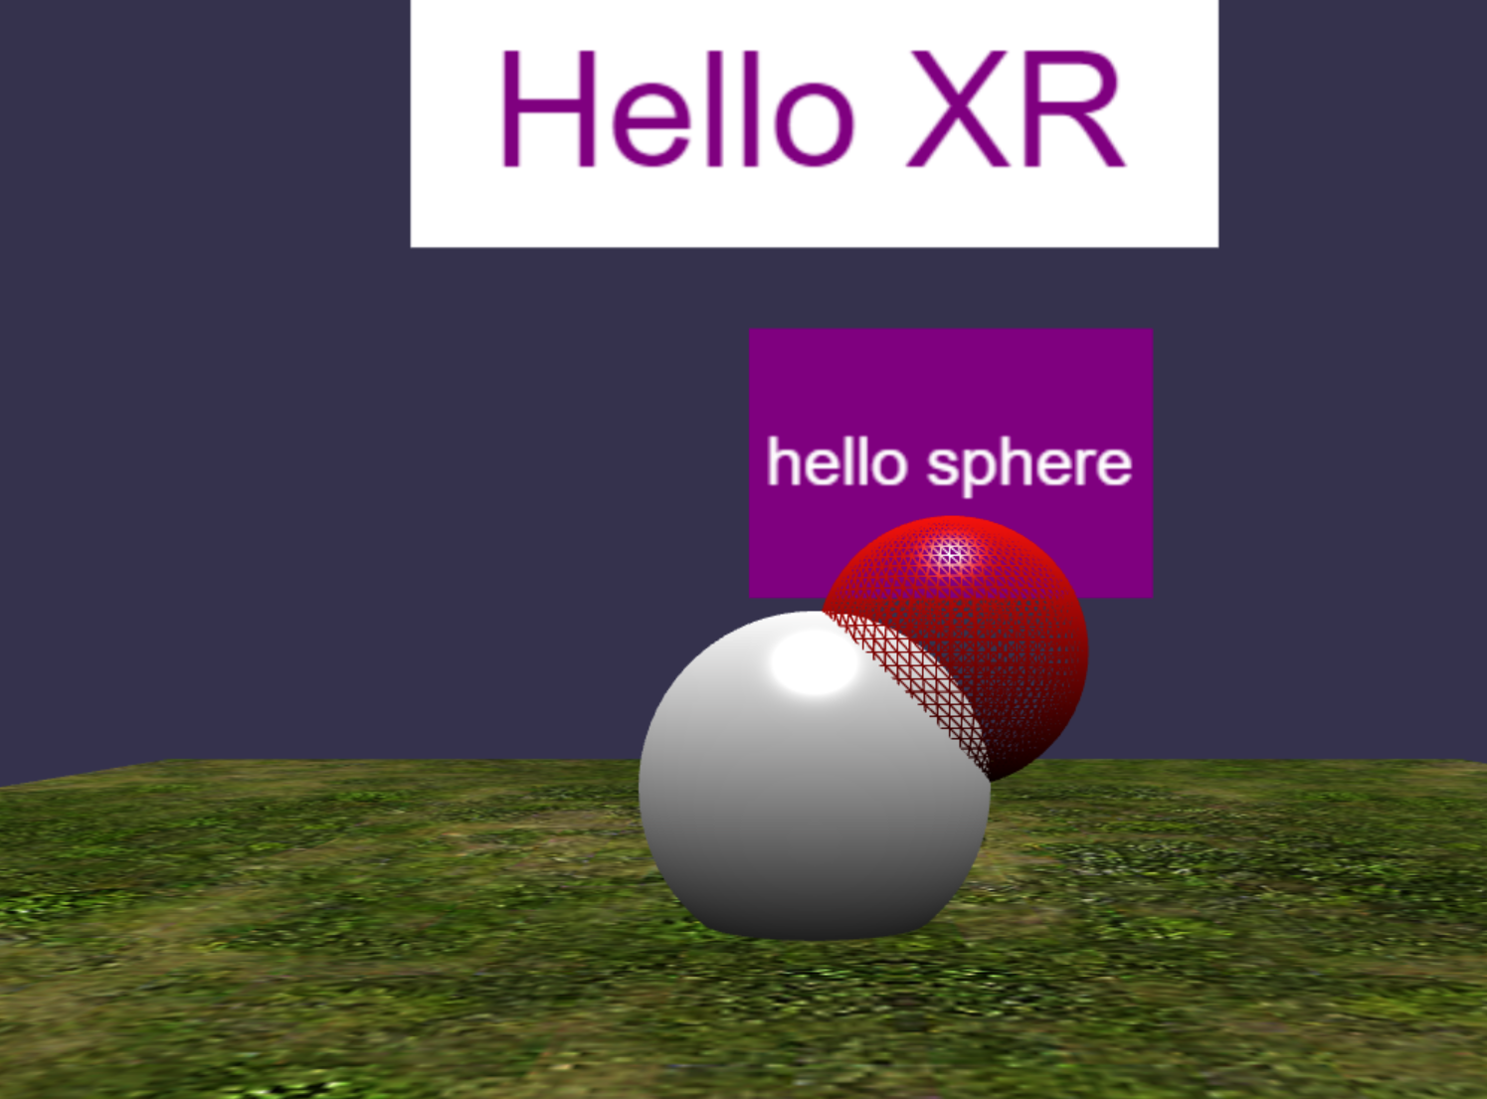

## Observables (Displaying distance)

**app.ts**

Add the following codes:

//3. create observer (Display distance on text block)

    const observer = new Observer<number>((distance) => {

      helloSphere.label.textBlock.text = "d: " + distance.toFixed(2)

    }, -1);

    onDistanceChangeObservable.observers.push(observer)

Here:

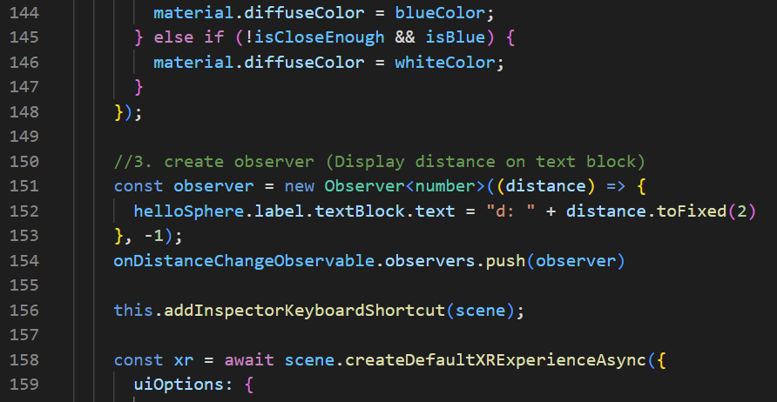

**Check**

When you drag the “helloSphere” Object around, the purple text block above the object will display the distance from the “helloSphere” Object to the “sphere” Object.

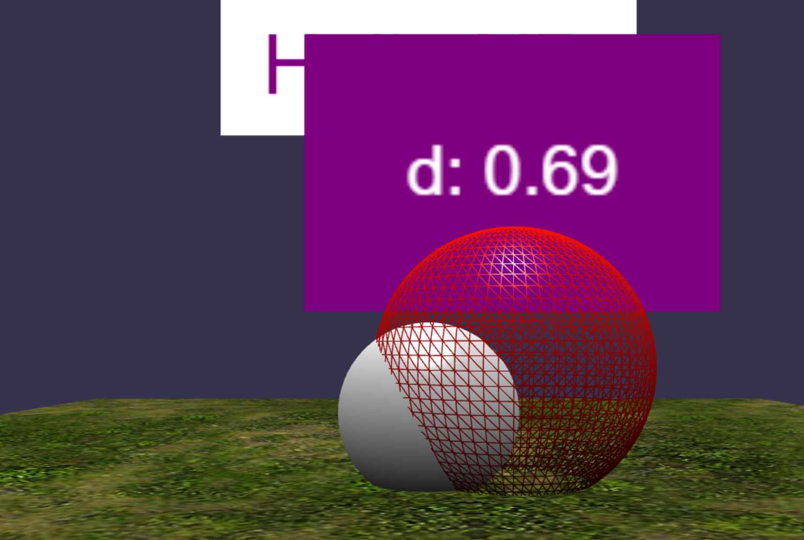

## Coroutines

**app.ts**

Comment out the following codes:

//onDistanceChangeObservable.observers.push(observer)

Add the following codes:

//4. add observer using coroutine

    const addObserverCoroutine = function* () {

      console.log("frame " + scene.getFrameId() + ": do nothing");

      yield;

      console.log("frame " + scene.getFrameId() + ": add observer");

      onDistanceChangeObservable.observers.push(observer);

      yield;

      console.log("frame " + scene.getFrameId() + ": do nothing");

    };

    scene.onBeforeRenderObservable.runCoroutineAsync(addObserverCoroutine());

    const coroutine = function* () {

      (async function () {

        await Tools.DelayAsync(2000);

        console.log("frame " + scene.getFrameId() + ": fn 1");

      })();

      yield;

      (async function () {

        await Tools.DelayAsync(2000);

        console.log("frame " + scene.getFrameId() + ": fn 2");

      })();

      yield;

      (async function () {

        console.log("frame " + scene.getFrameId() + ": fn 3");

      })();

      yield Tools.DelayAsync(1000);

      (async function () {

        console.log("frame " + scene.getFrameId() + ": fn 4");

      })();

    };

    scene.onBeforeRenderObservable.runCoroutineAsync(coroutine());

Here:

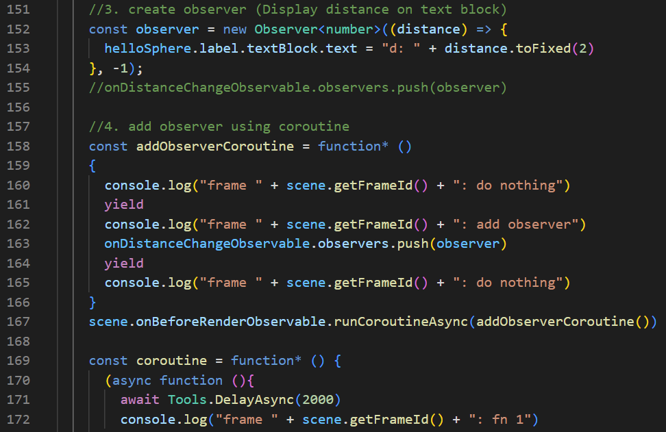

**Check**

You should see the “hello sphere” text shown on the purple text block above the “helloSphere” Object.

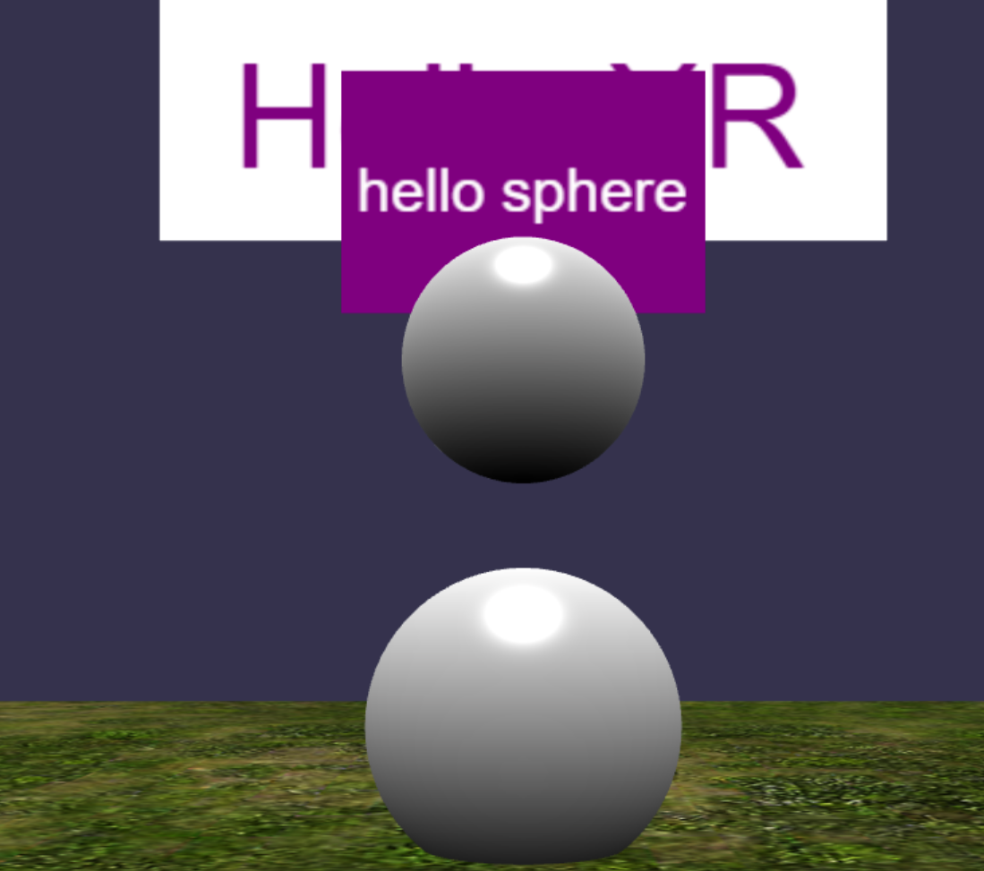

When you drag the “helloSphere” Object around, the purple text block above the object will display the distance from the “helloSphere” Object to the “sphere” Object.

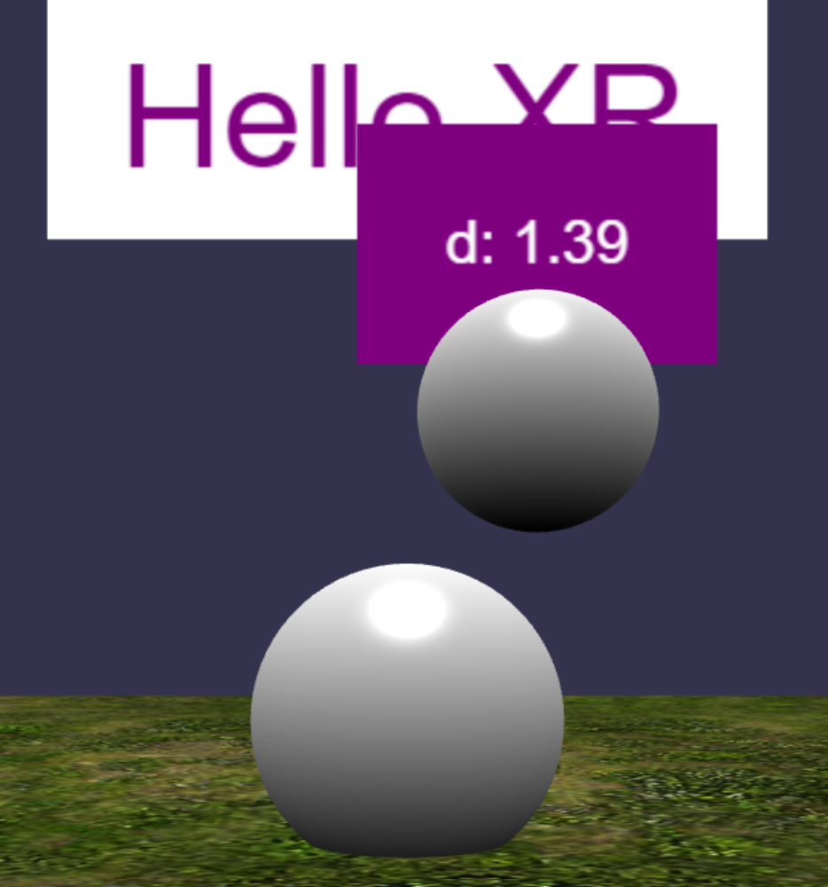

You should also see the following output printed on the Console tab in the order listed below.

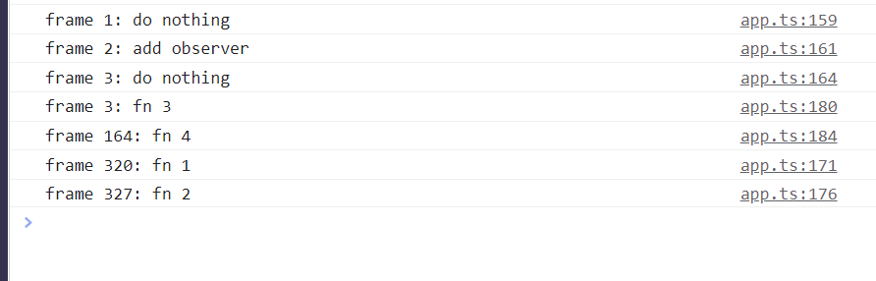

## Locomotion

**app.ts**

Add the following codes:

 const featureManager = xr.baseExperience.featuresManager;

    console.log(WebXRFeaturesManager.GetAvailableFeatures());

    //locomotion

    const movement = MovementMode.Teleportation; //Teleportation, Contoller, Walk

    this.initLocomotion(movement, xr, featureManager, ground, scene);

Here:

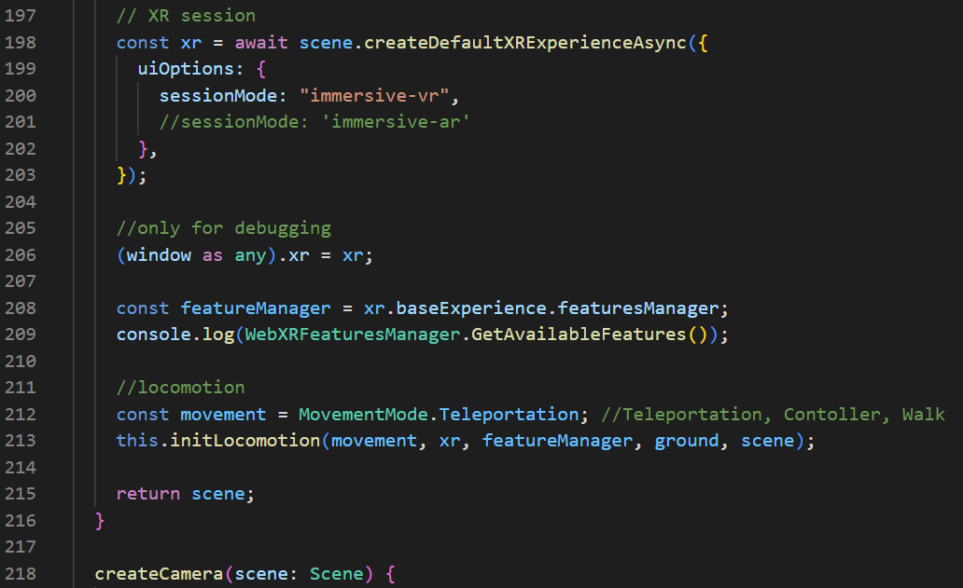

Add the following code:

initLocomotion(

    movement: MovementMode,

    xr: WebXRDefaultExperience,

    featureManager: WebXRFeaturesManager,

    ground: Mesh,

    scene: Scene

  ) {

    switch (movement) {

      case MovementMode.Teleportation:

        console.log("movement mode: teleportation");

        const teleportation = featureManager.enableFeature(

          WebXRFeatureName.TELEPORTATION,

          "stable",

          {

            xrInput: xr.input,

            floorMeshes: [ground],

            timeToTeleport: 2000,

            useMainComponentOnly: true,

            defaultTargetMeshOptions: {

              teleportationFillColor: "#55FF99",

              teleportationBorderColor: "blue",

              torusArrowMaterial: ground.material,

            },

          },

          true,

          true

        ) as WebXRMotionControllerTeleportation;

        teleportation.parabolicRayEnabled = true;

        teleportation.parabolicCheckRadius = 2;

        break;

      case MovementMode.Contoller:

        console.log("movement mode: controller");

        featureManager.disableFeature(WebXRFeatureName.TELEPORTATION);

        featureManager.enableFeature(WebXRFeatureName.MOVEMENT, "latest", {

          xrInput: xr.input,

        });

        break;

      case MovementMode.Walk:

        console.log("movement mode: walk");

        featureManager.disableFeature(WebXRFeatureName.TELEPORTATION);

        const xrRoot = new TransformNode("xr root", scene);

        xr.baseExperience.camera.parent = xrRoot;

        featureManager.enableFeature(

          WebXRFeatureName.WALKING_LOCOMOTION,

          "latest",

          {

            locomotionTarget: xrRoot,

          }

        );

        break;

    }

  }

Here:

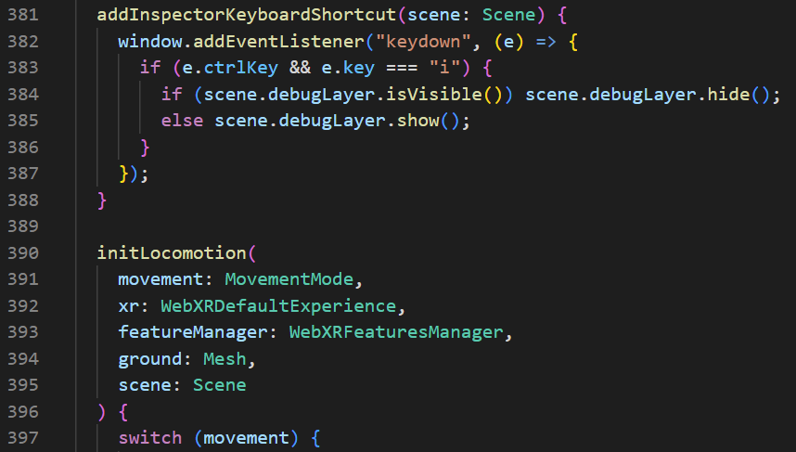

Add the following codes (at the bottom of the .ts file):

enum MovementMode {

  Teleportation,

  Contoller,

  Walk,

}

Here:

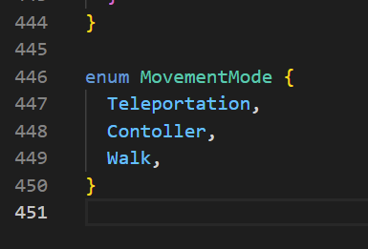

**Check**

Get into VR mode (clicking on the VR Goggles Logo at the bottom right), and open up the WebXR extension.

Tip:

To disable to split screen, uncheck the “Stereo effect”.

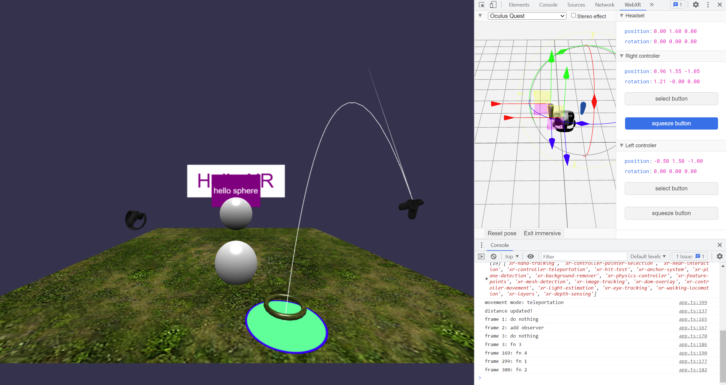

Testing Teleportation:

Aim one of your controllers upwards and press on the squeeze button of that controller. You should see a ring with a green circle on the grass ground. After 2 seconds, you will teleport to that location.



Testing Controller (Movement) & Walk (Walking in place):

Unable to test → Requires Oculus Quest 2

## Hand Tracking (Requires Oculus Quest 2)

**app.ts**

Add the following codes:

//hand tracking (Requires Oculus Quest 2)

    try {

      featureManager.enableFeature(WebXRFeatureName.HAND_TRACKING, "latest", {

        xrInput: xr.input,

        jointMeshes: {

          disableDefaultHandMesh: false,

          // disableDefaultHandMesh: true,

        },

      });

    } catch (error) {

      console.log(error);

    }

Here:

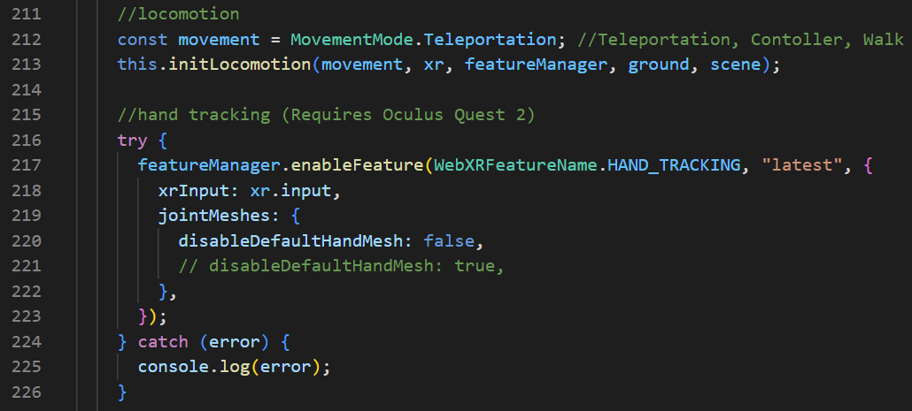

**How it looks on Oculus Quest 2:**

disableDefaultHandMesh: false,

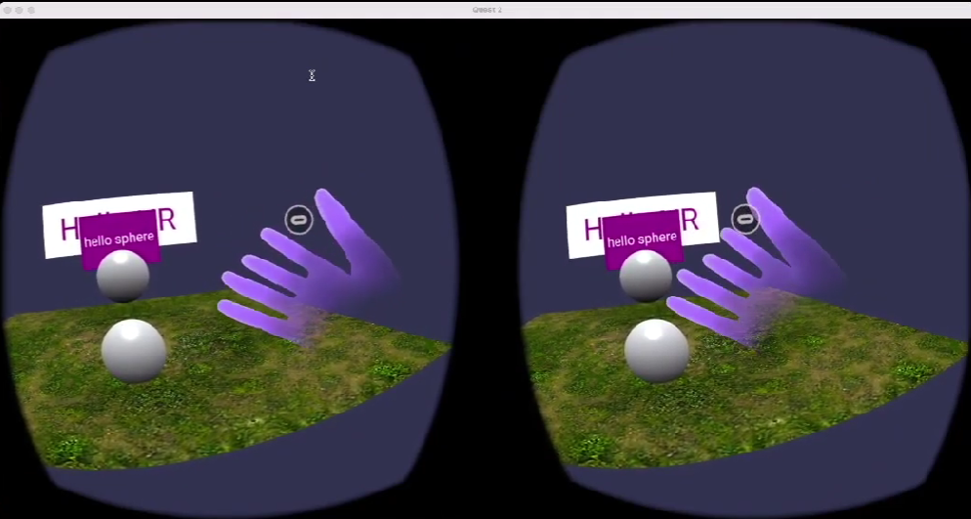

disableDefaultHandMesh: true,

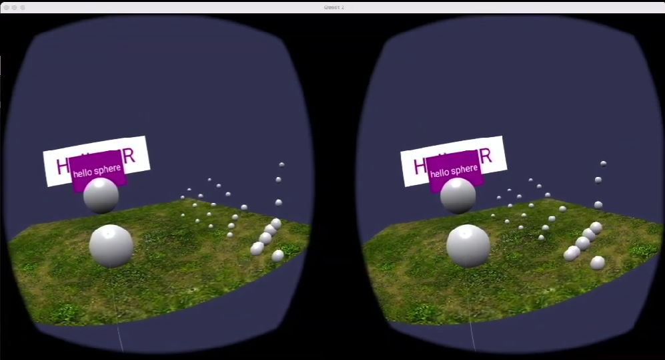

When you pinch on the “helloSphere” Object, you should be able to move the Sphere around.

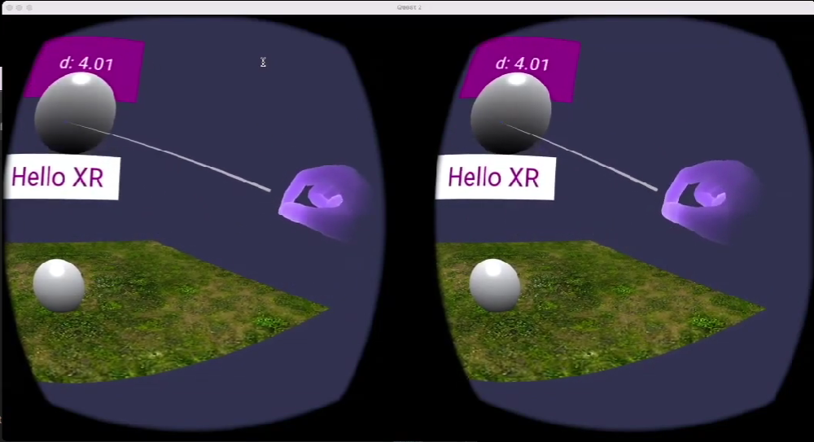

## Bimanual interaction (Requires Oculus Quest 2)

**app.ts**

Add the following codes:

//multiple pointer scale

    const multiPointerScaleBehavior = new MultiPointerScaleBehavior()

    helloSphere.addBehavior(multiPointerScaleBehavior);

Here:

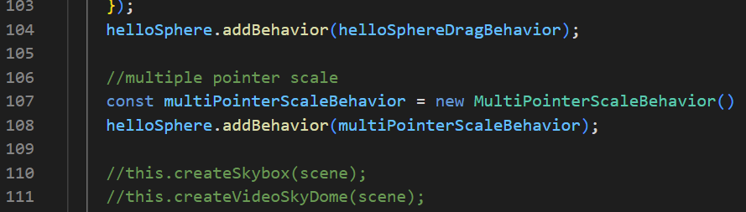

**How it behaves on Oculus Quest 2:**

You can use one of the controllers to move the “helloSphere” Object around, while the other controller to scale the Sphere bigger/smaller.

Using the left controller to Move the Sphere around, and the right controller to Scale:

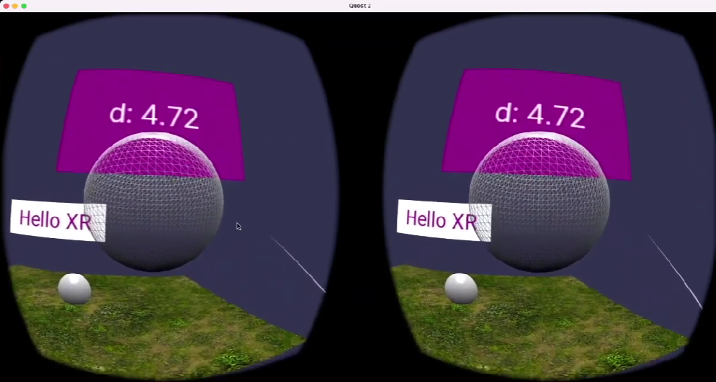

## Gizmo (Not Working for me! ☹)

**app.ts**

Add the following codes:

  //more behaviors

    //default gizmo

    const gizmoManager = new GizmoManager(scene)

    //gizmoManager.positionGizmoEnabled = true

    //gizmoManager.rotationGizmoEnabled = true

    //gizmoManager.scaleGizmoEnabled = true

    gizmoManager.boundingBoxGizmoEnabled = true

Here:

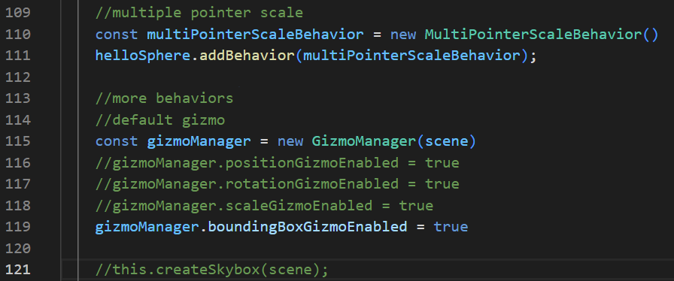

**How it should look like on the Web App:**

When you select the object, the gizmo feature should be shown on the object.

When you enable:

gizmoManager.positionGizmoEnabled = true

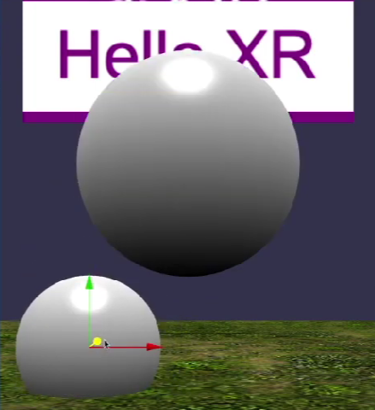

gizmoManager.rotationGizmoEnabled = true

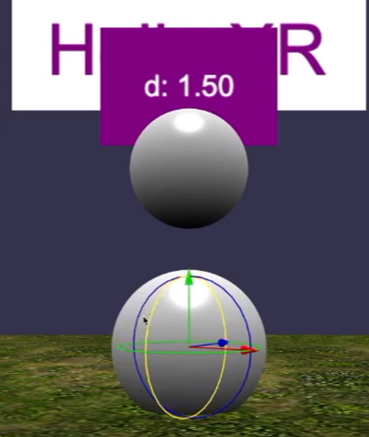

gizmoManager.scaleGizmoEnabled = true

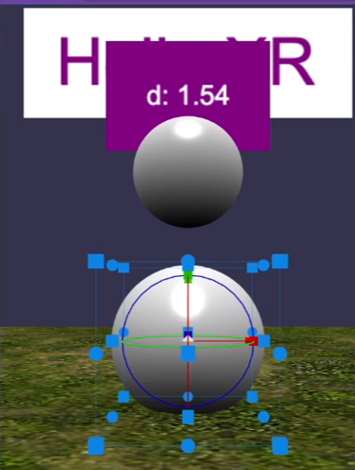

gizmoManager.boundingBoxGizmoEnabled = true

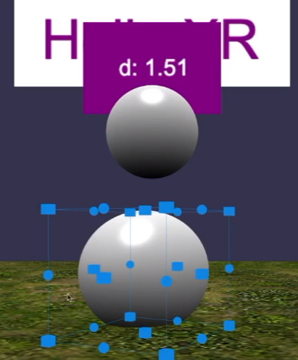

## Natural Grabbing

**app.ts**

Add the following codes:

 //hand/controller drag

    let mesh: AbstractMesh;

    xr.input.onControllerAddedObservable.add((controller) => {

      controller.onMotionControllerInitObservable.add((motionController) => {

        // const ids = motionController.getComponentIds()

        // const trigger = motionController.getComponent(ids[0])

        const trigger = motionController.getComponentOfType("trigger");

        trigger.onButtonStateChangedObservable.add(() => {

          if (trigger.changes.pressed) {

            if (

              (mesh = xr.pointerSelection.getMeshUnderPointer(

                controller.uniqueId

              ))

            ) {

              console.log("mesh under controller pointer: " + mesh.name);

              if (mesh.name !== "ground") {

                const distance = Vector3.Distance(

                  motionController.rootMesh.getAbsolutePosition(),

                  mesh.getAbsolutePosition()

                );

                console.log("distance: " + distance);

                if (distance < 1) {

                  mesh.setParent(motionController.rootMesh);

                  console.log("grab mesh: " + mesh.name);

                }

              }

            } else {

              if (mesh && mesh.parent) {

                mesh.setParent(null);

                console.log("release mesh: " + mesh.name);

              }

            }

          }

        });

      });

    });

Here:

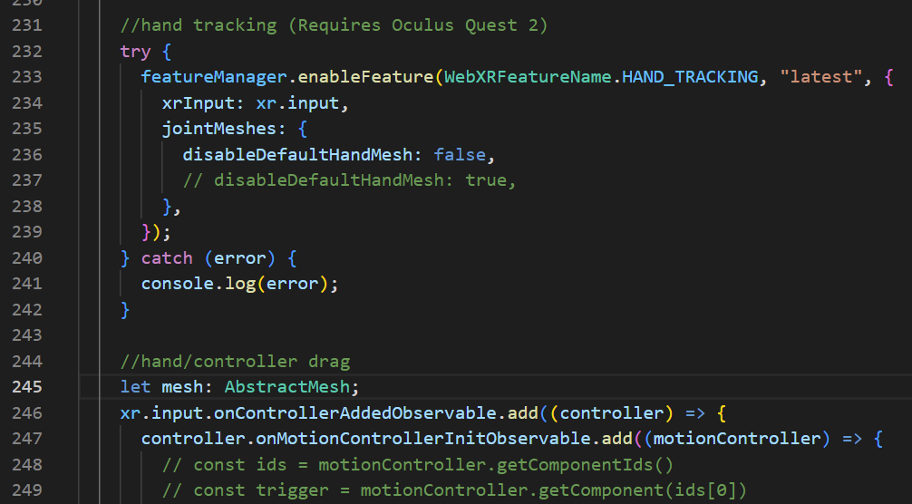

**Check**

When you select any object on the screen using a controller, the object will be “tagged” to the controller. By translating/rotating the controller, the object that is “tagged” will behave in the same way.

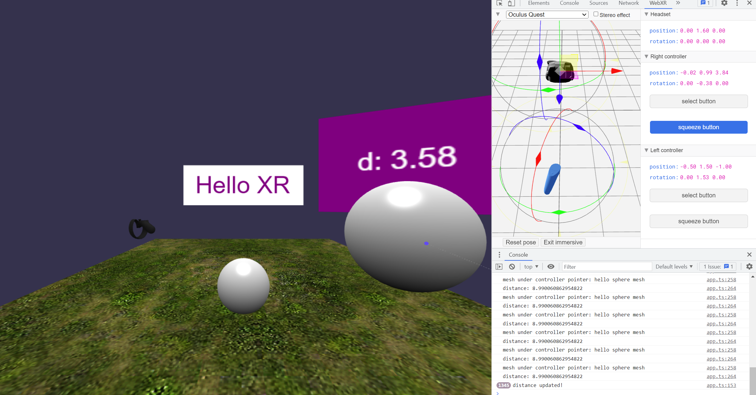

## Final Code Changes

### webpack.json

const path = require("path");

const HtmlWebpackPlugin = require('html-webpack-plugin')

const CopyPlugin = require('copy-webpack-plugin')

module.exports = {

    entry: './src/index.ts',

    output: {

        filename: 'index.js',

        path: path.resolve(__dirname, 'dist')

    },

    resolve: {

        extensions: [".ts", ".js"]

    },

    module: {

        rules: [

            { test: /\.tsx?$/, loader: "ts-loader" }

        ]

    },

    mode: "development",

    devtool: 'inline-source-map',

    devServer: {

        // static: true,

        port: 3000,

        server: 'http'

    },

    plugins: [

        new HtmlWebpackPlugin({

            template: path.resolve(__dirname,'src/index.html')

        }),

        new CopyPlugin({

            patterns: [

                { from: path.resolve(__dirname, 'public')}

            ]

        }),

    ]

};

### tsconfig.json

{

    "compilerOptions": {

        "target": "es5",

        "module": "commonjs",

        "noResolve": false,

        "noImplicitAny": false,

        "removeComments": true,

        "preserveConstEnums": true,

        "sourceMap": true,

        "experimentalDecorators": true,

        "isolatedModules": false,

        "lib": [

            "dom",

            "es2015.promise",

            "es5"

        ],

        //"declaration": true,

        "outDir": "./src",

        "types": [

            "babylonjs",

            "babylonjs-gui",

            "babylonjs-materials"

        ]

    },

    "files": [

        "./src/index.ts"

    ]

}

### app.ts

import {

  ArcRotateCamera,

  Color3,

  CubeTexture,

  Engine,

  MeshBuilder,

  Scene,

  StandardMaterial,

  Texture,

  Vector3,

  UniversalCamera,

  HemisphericLight,

  PointLight,

  VideoDome,

  SceneLoader,

  AbstractMesh,

  Animation,

  ParticleSystem,

  Color4,

  Sound,

  PointerDragBehavior,

  ActionManager,

  Observable,

  Observer,

  Tools,

  WebXRFeaturesManager,

  WebXRDefaultExperience,

  Mesh,

  WebXRFeatureName,

  WebXRMotionControllerTeleportation,

  TransformNode,

  MultiPointerScaleBehavior,

  GizmoManager,

  PointerEventTypes,

} from "babylonjs";

import { AdvancedDynamicTexture, TextBlock } from "babylonjs-gui";

import "babylonjs-loaders";

import { HelloSphere, TextPlane } from "./components/meshes";

export class App {

  private engine: Engine;

  private canvas: HTMLCanvasElement;

  private sound: Sound;

  constructor(engine: Engine, canvas: HTMLCanvasElement) {

    this.engine = engine;

    this.canvas = canvas;

    console.log("app is running");

  }

  async createScene() {

    const scene = new Scene(this.engine);

    scene.createDefaultCameraOrLight(false, true, true);

    //this.createCamera(scene)

    //this.createLights(scene)

    scene.actionManager = new ActionManager(scene);

    //simple sphere

    const sphere = MeshBuilder.CreateSphere("sphere", { diameter: 1.3 }, scene);

    sphere.position.y = -0.5;

    sphere.position.z = 5;

    //this.loadModel(scene)

    //this.addSounds(scene)

    this.createText(scene);

    //hello sphere

    const helloSphere = new HelloSphere("hello sphere", { diameter: 1 }, scene);

    helloSphere.position.set(0, 1, 5);

    helloSphere.sayHello("this a test.");

    helloSphere.isPickable = true;

    //ground

    const groundMaterial = new StandardMaterial("ground material", scene);

    groundMaterial.backFaceCulling = true;

    groundMaterial.diffuseTexture = new Texture(

      "assets/textures/grass.png",

      scene

    );

    const ground = MeshBuilder.CreateGround(

      "ground",

      { width: 12, height: 12 },

      scene

    );

    ground.material = groundMaterial;

    ground.position.set(0, -1, 8);

    //interactions

    //use behaviors

    const pointerDragBehavior = new PointerDragBehavior({

      dragPlaneNormal: Vector3.Up(),

    });

    pointerDragBehavior.onDragStartObservable.add((evtData) => {

      console.log(

        "drag start: pointer id -" + pointerDragBehavior,

        evtData.pointerId

      );

      console.log(evtData);

    });

    sphere.addBehavior(pointerDragBehavior);

    const helloSphereDragBehavior = new PointerDragBehavior({

      dragPlaneNormal: Vector3.Backward(),

    });

    helloSphere.addBehavior(helloSphereDragBehavior);

    //multiple pointer scale

    const multiPointerScaleBehavior = new MultiPointerScaleBehavior();

    helloSphere.addBehavior(multiPointerScaleBehavior);

    //more behaviors

    //default gizmo

    const gizmoManager = new GizmoManager(scene);

    // gizmoManager.positionGizmoEnabled = true

    // gizmoManager.rotationGizmoEnabled = true

    // gizmoManager.scaleGizmoEnabled = true

    gizmoManager.boundingBoxGizmoEnabled = true;

    //this.createSkybox(scene);

    //this.createVideoSkyDome(scene);

    //use observables (@ Can be shifted to hello-mesh.ts class)

    //1. create an observable for detecting intersections

    const onIntersectObservable = new Observable<boolean>();

    scene.registerBeforeRender(function () {

      const isIntersecting = sphere.intersectsMesh(helloSphere, true, true);

      onIntersectObservable.notifyObservers(isIntersecting);

    });

    helloSphere.onInterectObservable = onIntersectObservable;

    const redColor = Color3.Red();

    const whiteColor = Color3.White();

    helloSphere.onInterectObservable.add((isIntersecting) => {

      const material = helloSphere.mesh.material as StandardMaterial;

      const isRed = material.diffuseColor === redColor;

      if (isIntersecting && !isRed) {

        material.diffuseColor = redColor;

      } else if (!isIntersecting && isRed) {

        material.diffuseColor = whiteColor;

      }

    });

    //2. create an observable for check distance

    const onDistanceChangeObservable = new Observable<number>();

    let previousState: number = null;

    scene.onBeforeRenderObservable.add(() => {

      const currentState = Vector3.Distance(

        sphere.position,

        helloSphere.position

      );

      if (currentState !== previousState) {

        console.log("distance updated!");

        previousState = currentState;

        onDistanceChangeObservable.notifyObservers(currentState);

      }

    });

    helloSphere.onDistanceChangeObservable = onDistanceChangeObservable;

    const blueColor = Color3.Blue();

    helloSphere.onDistanceChangeObservable.add((distance) => {

      const isCloseEnough = distance <= 1.2;

      const material = helloSphere.mesh.material as StandardMaterial;

      const isBlue = material.diffuseColor === blueColor;

      const isRed = material.diffuseColor === redColor;

      if (isCloseEnough && !isBlue && !isRed) {

        material.diffuseColor = blueColor;

      } else if (!isCloseEnough && isBlue) {

        material.diffuseColor = whiteColor;

      }

    });

    //3. create observer (Display distance on text block)

    const observer = new Observer<number>((distance) => {

      helloSphere.label.textBlock.text = "d: " + distance.toFixed(2);

    }, -1);

    //onDistanceChangeObservable.observers.push(observer)

    //4. add observer using coroutine

    const addObserverCoroutine = function* () {

      console.log("frame " + scene.getFrameId() + ": do nothing");

      yield;

      console.log("frame " + scene.getFrameId() + ": add observer");

      onDistanceChangeObservable.observers.push(observer);

      yield;

      console.log("frame " + scene.getFrameId() + ": do nothing");

    };

    scene.onBeforeRenderObservable.runCoroutineAsync(addObserverCoroutine());

    const coroutine = function* () {

      (async function () {

        await Tools.DelayAsync(2000);

        console.log("frame " + scene.getFrameId() + ": fn 1");

      })();

      yield;

      (async function () {

        await Tools.DelayAsync(2000);

        console.log("frame " + scene.getFrameId() + ": fn 2");

      })();

      yield;

      (async function () {

        console.log("frame " + scene.getFrameId() + ": fn 3");

      })();

      yield Tools.DelayAsync(1000);

      (async function () {

        console.log("frame " + scene.getFrameId() + ": fn 4");

      })();

    };

    scene.onBeforeRenderObservable.runCoroutineAsync(coroutine());

    this.addInspectorKeyboardShortcut(scene);

    // XR session

    const xr = await scene.createDefaultXRExperienceAsync({

      uiOptions: {

        sessionMode: "immersive-vr",

        //sessionMode: 'immersive-ar'

      },

    });

    //only for debugging

    (window as any).xr = xr;

    const featureManager = xr.baseExperience.featuresManager;

    console.log(WebXRFeaturesManager.GetAvailableFeatures());

    //locomotion

    const movement = MovementMode.Teleportation; //Teleportation, Contoller, Walk

    this.initLocomotion(movement, xr, featureManager, ground, scene);

    //hand tracking (Requires Oculus Quest 2)

    try {

      featureManager.enableFeature(WebXRFeatureName.HAND_TRACKING, "latest", {

        xrInput: xr.input,

        jointMeshes: {

          disableDefaultHandMesh: false,

          // disableDefaultHandMesh: true,

        },

      });

    } catch (error) {

      console.log(error);

    }

    //hand/controller drag

    let mesh: AbstractMesh;

    xr.input.onControllerAddedObservable.add((controller) => {

      controller.onMotionControllerInitObservable.add((motionController) => {

        // const ids = motionController.getComponentIds()

        // const trigger = motionController.getComponent(ids[0])

        const trigger = motionController.getComponentOfType("trigger");

        trigger.onButtonStateChangedObservable.add(() => {

          if (trigger.changes.pressed) {

            if (

              (mesh = xr.pointerSelection.getMeshUnderPointer(

                controller.uniqueId

              ))

            ) {

              console.log("mesh under controller pointer: " + mesh.name);

              if (mesh.name !== "ground") {

                const distance = Vector3.Distance(

                  motionController.rootMesh.getAbsolutePosition(),

                  mesh.getAbsolutePosition()

                );

                console.log("distance: " + distance);

                if (distance < 1) {

                  mesh.setParent(motionController.rootMesh);

                  console.log("grab mesh: " + mesh.name);

                }

              }

            } else {

              if (mesh && mesh.parent) {

                mesh.setParent(null);

                console.log("release mesh: " + mesh.name);

              }

            }

          }

        });

      });

    });

    return scene;

  }

  createCamera(scene: Scene) {

    //const camera = new ArcRotateCamera('arcCamera', -Math.PI/5, -Math.PI/2, 5, Vector3.Zero(), scene)

    const camera = new UniversalCamera(

      "uniCamera",

      new Vector3(0, 0, -5),

      scene

    );

    camera.attachControl(this.canvas, true);

  }

  createLights(scene: Scene) {

    const hemiLight = new HemisphericLight(

      "hemLight",

      new Vector3(-1, 1, 0),

      scene

    );

    hemiLight.intensity = 0.5;

    hemiLight.diffuse = new Color3(1, 1, 1);

    const pointLight = new PointLight(

      "pointLight",

      new Vector3(0, 1.5, 2),

      scene

    );

    pointLight.intensity = 1;

    pointLight.diffuse = new Color3(1, 0, 0);

  }

  loadModel(scene: Scene) {

    SceneLoader.ImportMeshAsync("", "assets/models/", "H2O.glb", scene).then(

      (result) => {

        const root = result.meshes[0];

        root.id = "h2oRoot";

        root.name = "h2oRoot";

        root.position.y = -1;

        root.rotation = new Vector3(0, 0, Math.PI);

        root.scaling.setAll(1.5);

        this.createAnimation(scene, root);

        this.createParticles(scene);

      }

    );

  }

  createAnimation(scene: Scene, model: AbstractMesh) {

    const animation = new Animation(

      "rotationAnima",

      "rotation",

      30,

      Animation.ANIMATIONTYPE_VECTOR3,

      Animation.ANIMATIONLOOPMODE_CYCLE

    );

    const keyFrames = [

      { frame: 0, value: new Vector3(0, 0, 0) },

      { frame: 30, value: new Vector3(0, 2 * Math.PI, 0) },

    ];

    animation.setKeys(keyFrames);

    model.animations = [];

    model.animations.push(animation);

    scene.beginAnimation(model, 0, 30, true);

  }

  createParticles(scene: Scene) {

    const particleSystem = new ParticleSystem("particles", 5000, scene);

    particleSystem.particleTexture = new Texture(

      "assets/textures/flare.png",

      scene

    );

    particleSystem.emitter = new Vector3(0, 0, 0);

    particleSystem.minEmitBox = new Vector3(0, 0, 0);

    particleSystem.maxEmitBox = new Vector3(0, 0, 0);

    particleSystem.color1 = new Color4(0.7, 0.8, 1.0, 1.0);

    particleSystem.color2 = new Color4(0.3, 0.5, 1.0, 1.0);

    particleSystem.blendMode = ParticleSystem.BLENDMODE_ONEONE;

    particleSystem.minSize = 0.01;

    particleSystem.maxSize = 0.05;

    particleSystem.minLifeTime = 0.3;

    particleSystem.maxLifeTime = 1.5;

    particleSystem.emitRate = 1500;

    particleSystem.direction1 = new Vector3(-1, 8, 1);

    particleSystem.direction2 = new Vector3(1, 8, -1);

    particleSystem.minEmitPower = 0.2;

    particleSystem.maxEmitPower = 0.8;

    particleSystem.updateSpeed = 0.01;

    particleSystem.gravity = new Vector3(0, -9.8, 0);

    particleSystem.start();

  }

  addSounds(scene: Scene) {

    const music = new Sound(

      "music",

      "assets/sounds/hello-xr.mp3",

      scene,

      null,

      {

        loop: true,

        autoplay: false,

      }

    );

    this.sound = new Sound("sound", "assets/sounds/button.mp3", scene, null);

  }

  createText(scene: Scene) {

    const helloPlane = new TextPlane(

      "hello plane",

      3,

      1,

      0,

      2,

      5,

      "Hello XR",

      "white",

      "purple",

      60,

      scene

    );

    helloPlane.textBlock.onPointerUpObservable.add((evtData) => {

      alert("Hello Text at: \n x: " + evtData.x + " y:" + evtData.y);

    });

    helloPlane.textBlock.onPointerDownObservable.add(() => {

      this.sound.play();

    });

  }

  createSkybox(scene: Scene) {

    const skybox = MeshBuilder.CreateBox("skybox", { size: 1000 }, scene);

    const skyboxMaterial = new StandardMaterial("skybox-mat");

    skyboxMaterial.backFaceCulling = false;

    skyboxMaterial.reflectionTexture = new CubeTexture(

      "assets/textures/skybox",

      scene

    );

    skyboxMaterial.reflectionTexture.coordinatesMode = Texture.SKYBOX_MODE;

    skyboxMaterial.diffuseColor = new Color3(0, 0, 0);

    skyboxMaterial.specularColor = new Color3(0, 0, 0);

    skybox.material = skyboxMaterial;

  }

  createVideoSkyDome(scene: Scene) {

    const dome = new VideoDome(

      "videoDome",

      "assets/videos/bridge-360.mp4",

      {

        resolution: 32,

        size: 1000,

      },

      scene

    );

  }

  addInspectorKeyboardShortcut(scene: Scene) {

    window.addEventListener("keydown", (e) => {

      if (e.ctrlKey && e.key === "i") {

        if (scene.debugLayer.isVisible()) scene.debugLayer.hide();

        else scene.debugLayer.show();

      }

    });

  }

  initLocomotion(

    movement: MovementMode,

    xr: WebXRDefaultExperience,

    featureManager: WebXRFeaturesManager,

    ground: Mesh,

    scene: Scene

  ) {

    switch (movement) {

      case MovementMode.Teleportation:

        console.log("movement mode: teleportation");

        const teleportation = featureManager.enableFeature(

          WebXRFeatureName.TELEPORTATION,

          "stable",

          {

            xrInput: xr.input,

            floorMeshes: [ground],

            timeToTeleport: 2000,

            useMainComponentOnly: true,

            defaultTargetMeshOptions: {

              teleportationFillColor: "#55FF99",

              teleportationBorderColor: "blue",

              torusArrowMaterial: ground.material,

            },

          },

          true,

          true

        ) as WebXRMotionControllerTeleportation;

        teleportation.parabolicRayEnabled = true;

        teleportation.parabolicCheckRadius = 2;

        break;

      case MovementMode.Contoller:

        console.log("movement mode: controller");

        featureManager.disableFeature(WebXRFeatureName.TELEPORTATION);

        featureManager.enableFeature(WebXRFeatureName.MOVEMENT, "latest", {

          xrInput: xr.input,

        });

        break;

      case MovementMode.Walk:

        console.log("movement mode: walk");

        featureManager.disableFeature(WebXRFeatureName.TELEPORTATION);

        const xrRoot = new TransformNode("xr root", scene);

        xr.baseExperience.camera.parent = xrRoot;

        featureManager.enableFeature(

          WebXRFeatureName.WALKING_LOCOMOTION,

          "latest",

          {

            locomotionTarget: xrRoot,

          }

        );

        break;

    }

  }

}

enum MovementMode {

  Teleportation,

  Contoller,

  Walk,

}

### components\meshes\index.ts

export * from './text-plane'

export * from './hello-mesh'

### components\meshes\text-plane.ts

import { Mesh, MeshBuilder, Scene } from "babylonjs";

import { AdvancedDynamicTexture, TextBlock } from "babylonjs-gui";

export class TextPlane {

  public mesh: Mesh

  public textBlock: TextBlock;

  constructor(

    name: string,

    width: number,

    height: number,

    x: number,

    y: number,

    z: number,

    text: string,

    backgroundColor: string,

    textColor: string,

    fontSize: number,

    scene: Scene

  ) {

    const textPlane = MeshBuilder.CreatePlane(name + " text plane", {

      width: width,

      height: height,

    });

    textPlane.position.set(x, y, z);

    const planeTexture = AdvancedDynamicTexture.CreateForMesh(

      textPlane,

      width * 100,

      height * 100,

      false

    );

    planeTexture.background = backgroundColor;

    const planeText = new TextBlock(name + " plane text");

    planeText.text = text;

    planeText.color = textColor;

    planeText.fontSize = fontSize;

    planeTexture.addControl(planeText);

    this.mesh = textPlane

    this.textBlock = planeText

  }

}

### components\meshes\hello-mesh.ts

import {

  AbstractMesh,

  ActionManager,

  Color3,

  ExecuteCodeAction,

  InterpolateValueAction,

  Mesh,

  MeshBuilder,

  Observable,

  PredicateCondition,

  Scene,

  SetValueAction,

  StandardMaterial,

  Vector3,

} from "babylonjs";

import { TextPlane } from "./text-plane";

export interface HelloMesh {

  scene: Scene;

  mesh: Mesh;

  label: TextPlane;

  onDistanceChangeObservable: Observable<number>

  onInterectObservable: Observable<boolean>

  sayHello(message?: string): void;

}

export class HelloSphere extends AbstractMesh implements HelloMesh {

  scene: Scene;

  mesh: Mesh;

  label: TextPlane;

  onDistanceChangeObservable: Observable<number>

  onInterectObservable: Observable<boolean>

  constructor(name: string, options: { diameter: number }, scene: Scene) {

    super(name, scene);

    this.scene = scene;

    this.mesh = MeshBuilder.CreateSphere("hello sphere mesh", options, scene);

    this.mesh.material = new StandardMaterial("hello sphere material", scene);

    this.addChild(this.mesh);

    this.label = new TextPlane(

      "hello sphere label",

      1.5,

      1,

      0,

      options.diameter / 2 + 0.2,

      0,

      "hello sphere",

      "purple",

      "white",

      25,

      scene

    );

    this.addChild(this.label.mesh);

    this.initActions();

  }

  sayHello(message?: string): void {

    console.log("message from hello sphere: " + message);

  }

  private initActions() {

    const actionManager = (this.actionManager = new ActionManager(this.scene));

    actionManager.isRecursive = true;

    const light = this.scene.getLightById("default light");

    //Switch ON/OFF lights

    actionManager

      .registerAction(

        new InterpolateValueAction(

          ActionManager.OnPickDownTrigger,

          light,

          "diffuse",

          Color3.Black(),

          1000

        )

      )

      .then(

        new InterpolateValueAction(

          ActionManager.OnPickDownTrigger,

          light,

          "diffuse",

          Color3.White(),

          1000

        )

      );

    //Scale up sphere

    actionManager.registerAction(

      new InterpolateValueAction(

        ActionManager.OnPickDownTrigger,

        this,

        "scaling",

        new Vector3(2, 2, 2),

        1000,

        new PredicateCondition(actionManager, () => {

          return light.diffuse.equals(Color3.Black());

        })

      )

    );

    //Collision

    const otherMesh = this.scene.getMeshById("sphere");

    actionManager.registerAction(

      new SetValueAction(

        {

          trigger: ActionManager.OnIntersectionEnterTrigger,

          parameter: {

            mesh: otherMesh,

            usePreciseIntersection: true,

          },

        },

        this.mesh.material,

        "wireframe",

        true

      )

    );

    //Reset sphere

    this.scene.actionManager.registerAction(

      new ExecuteCodeAction(

        {

          trigger: ActionManager.OnKeyUpTrigger,

          parameter: "r",

        },

        () => {

          this.scaling.setAll(1);

          this.mesh.material.wireframe = false;

          console.log("r was pressed: reset " + this.name);

        }

      )

    );

  }

}